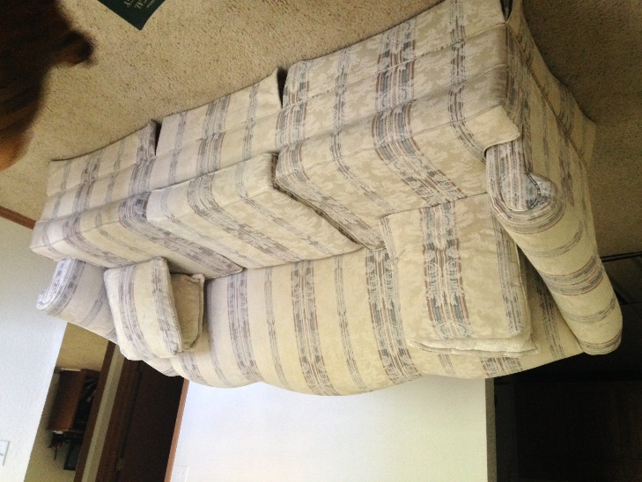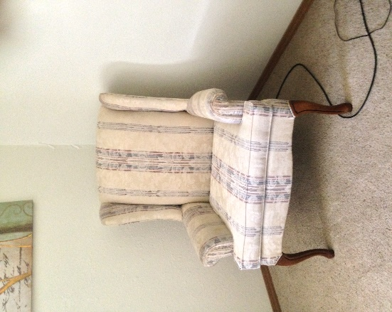

**Sofa and chair $120**

Moving Sale!!!

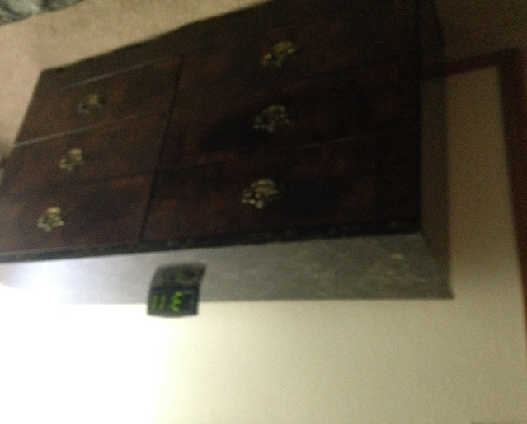 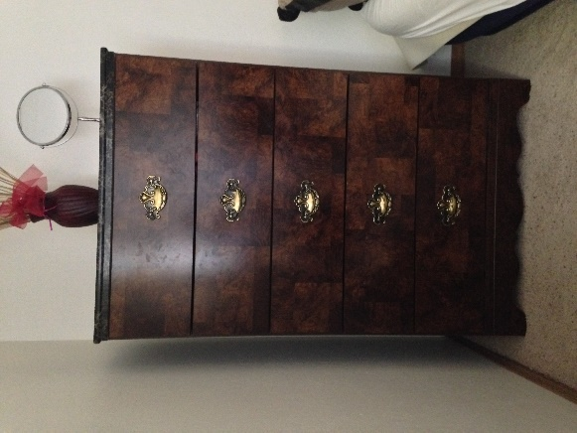

**Dresser and chest $100**

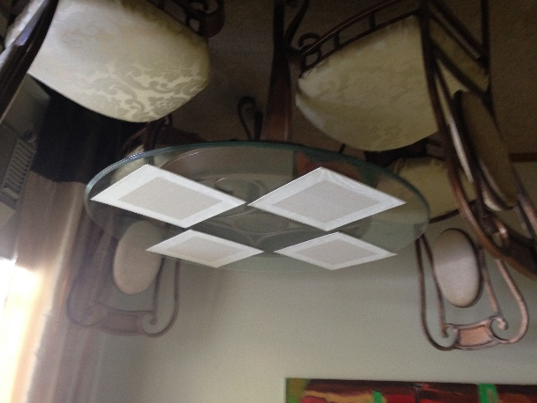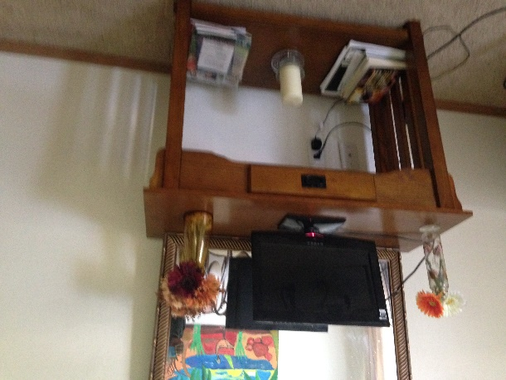

Call# 707-706-3489

Email ftzg2014@gmail.com

**15”Dynex TV $25**

**Mirror (43x33 in) $15**

**Side table $40**

**4 chair dining table $100**