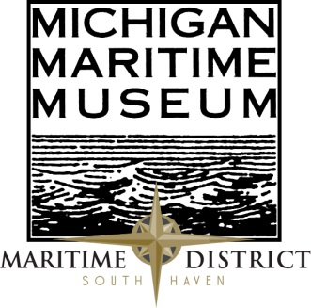
Contact: The Michigan Maritime Museum
Phone: 1-800-747-3810 or (269) 637-8078, Ext: 3
www.michiganmaritimemuseum.org
Email: volunteer@michiganmaritimemuseum.org

**FOR IMMEDIATE RELEASE**

Great Lakes Shipwreck Diver to Present at 2015 Lecture Series

The Michigan Maritime Museum will be holding the third lecture of their 2015 Lecture Series with speaker Jim Scholz. Scholz will be giving a presentation on his shipwreck diving experiences and discoveries in the Great Lakes during his presentation, “What Lies Beneath.”
Scholz has been a SCUBA diver for over 30 years, gaining his initial certification on a shipwreck in the cold, dark and deep North Atlantic Ocean off the coast of New Jersey. Shortly after, he moved to Michigan and started diving the Great Lakes, only to find that the shipwrecks are more abundant, better preserved, and the only place in the world where you can find fully intact wooden Lake Schooners waiting to be discovered. He has assisted in locating three shipwrecks in Lake Michigan and is currently President of the Southwest Michigan Underwater Preserve. His mission is to work to locate, identify, preserve, and educate the public on the shipwrecks and bottomlands of the Great Lakes, and the joy of diving the cold, fresh waters.
Scholz will be speaking on the Michigan Maritime Museum Campus on March 28th at 2pm. The lecture series will continue on the last Saturday of the following months and feature a variety of topics and speakers.

Admission is $8 for adults and $7 for seniors. There is no admission fee for Museum members. Light refreshments will be provided. Become a member and attend each additional lecture at no cost. It is the perfect time to become a member!

The Michigan Maritime Museum is dedicated to the preservation of Michigan Great Lakes waterways, maritime history, and culture. Located at the drawbridge in South Haven, the museum is a 501 (C3) organization and donations are tax deductible. For more information call 1-800-747-3810 or visit michiganmaritimemuseum.org.

Dear Editor: Following is a synopsis of the current press release designed for your “Calendar of Events” page or similar event listing feature

Event Name: 2015 Winter Lecture Series
Speaker: Jim Scholz
Date: March 28, 2015
Time: 2pm
Location: Michigan Maritime Museum Campus
Other Info: Admission is $8 for adults and $7 for seniors. There is no admission fee for Museum members. Light refreshments will be provided.
www.michiganmaritimemuseum.org

