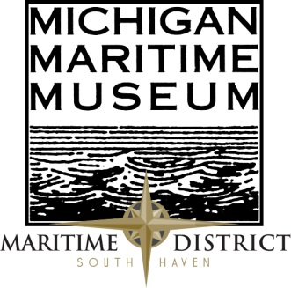
Contact: The Michigan Maritime Museum
Phone: 1-800-747-3810 or (269) 637-8078, Ext: 3
www.michiganmaritimemuseum.org
Email: volunteer@michiganmaritimemuseum.org

**FOR IMMEDIATE RELEASE**

100 Years Brings New Thoughts on the Eastland Disaster

The Michigan Maritime Museum is proud to present the fourth lecture of their 2015 Lecture Series with speaker Michael McCarthy. McCarthy will be giving a lecture on the 1915 Eastland disaster titled after his book, Ashes Under Water: The SS Eastland and the Shipwreck that Shook America.
This year marks the centennial of one of the nation's worst disasters, the 1915 sinking of the steamship Eastland in the Chicago River, with more passenger deaths than the Titanic. An astonishing 844 poor people perished on the Eastland—a ship still tied to its dock when it capsized.
McCarthy will be presenting on the content of his new book, Ashes Under Water: The SS Eastland and the Shipwreck that Shook America. For a century, the cause of the nearly forgotten tragedy had remained a mystery. McCarthy’s work offers a fresh, sinister explanation for the tragedy: that management neglected needed repairs to the stabilizing machinery of the ship.
Michael McCarthy, who learned to sail on Lake Michigan, is the author of The Sun Farmer and worked as a reporter and editor for the Wall Street Journal for twenty-two years. He lives in South Haven, Michigan.
McCarthy will be speaking on the Michigan Maritime Museum Campus on April 25th at 2pm. The lecture series will finish on the last Saturday of May. He will also be signing copies of his book at the event.

Admission is $8 for adults and $7 for seniors. There is no admission fee for Museum members. Light refreshments will be provided. Become a member and attend each additional lecture at no cost. It is the perfect time to become a member!

The Michigan Maritime Museum is dedicated to the preservation of Michigan Great Lakes waterways, maritime history, and culture. Located at the drawbridge in South Haven, the museum is a 501 (C3) organization and donations are tax deductible. For more information call 1-800-747-3810 or visit michiganmaritimemuseum.org.

Dear Editor: Following is a synopsis of the current press release designed for your “Calendar of Events” page or similar event listing feature

Event Name: 2015 Lecture Series
Speaker: Michael McCarthy
Date: April 25, 2015
Time: 2pm
Location: Michigan Maritime Museum Campus
Other Info: Admission is $8 for adults and $7 for seniors. There is no admission fee for Museum members. Light refreshments will be provided.
www.michiganmaritimemuseum.org

