To confirm if you have access to the report…

Please enter SWRXLRN in the ‘Go To…’ drop down box and hit return:

If you get the following screen you have access:

To run the report…

When access is granted (Beth can help you get access if you do not have it yet)…
- Walk to the 3rd block (‘Parameter Values’) by using the menu “Block” | “Next”or the keyboard short cut ‘CTRL-Page Down’ or toolbar.
- The first 4 parameters are the most important ones.
- Parameter 1-2: You can get a report for only one term by entering the same begin and ending term code, or you can run the report for a range of term (different term codes in each parameter).
- Parameter 3-4: Will determine if you get one sheet per term and if you get one line per student curriculum (refer to message at the end of the Parameter Values Block’.

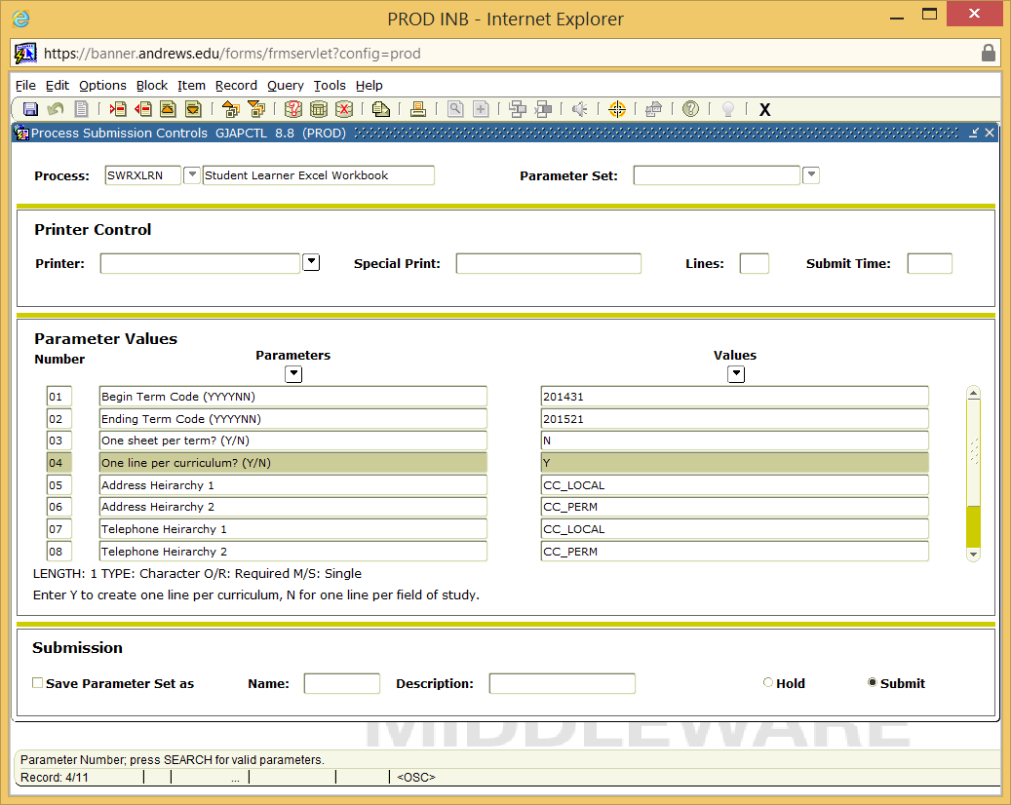

In order to submit the report you will need to be in the Submission Block and hit F10 (keyboard short-cut) or “Save”. You should see a number at the very button of the screen which is the job submission number.

Accessing and saving the report…

- After a good time, you should get an email letting you know that you job is done and report is ready or look in Jobsub Output for the results if email is not working.
- Follow the link and instructions (you will be prompted to enter your login information).
- Select the latest ‘.xls file’ from Banner output files for user your username:

- Click on the .xls file and save the file on your computer. If that fails, Right-click on the xls file and ‘save target as…’.
- It is now ready in your directory to be accessed at any time.

The report…

There are many columns in the report – demographic data, status codes, academic data and curriculum data. Some are self-explanatory and you might need help to interpret others. Feel free to call the functional support person if you have questions.

At this point it is your choice to:
- Hide or delete the columns you do not need.
- Use Excel menu to filter, sort or create pivot tables of the data as needed.

