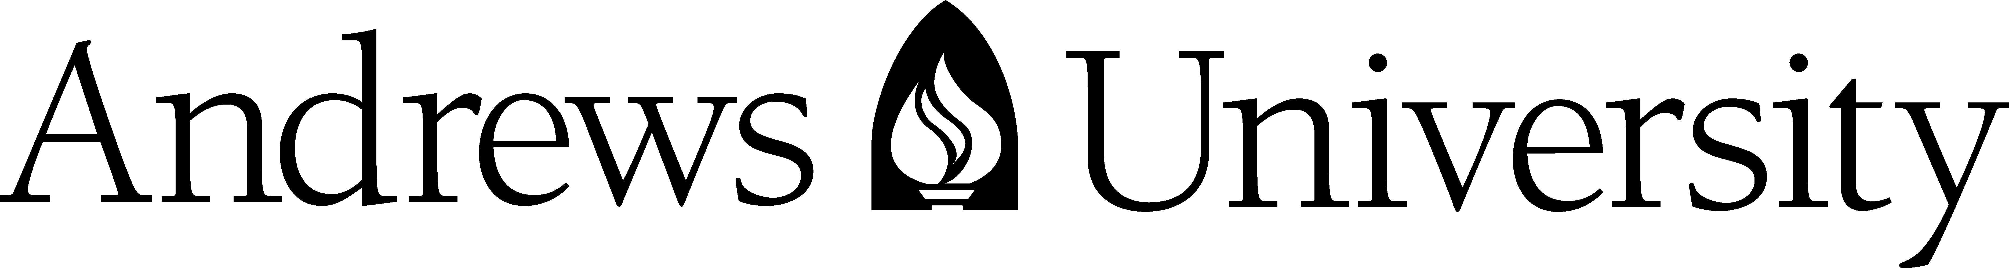

FACULTY RESEARCH GRANT: Final Report Form
May 1, 2023 – April 30, 2024

Submission Deadline: May 31, 2024

This form is to be used to report on the progress and outcomes of 2023-24 FRGs. Please submit completed report via email to research@andrews.edu.

Principal Investigator(s)
NAMES (Last, First, MI) | AU ID | DEPT | E-MAIL | TEL EXT | FACULTY STATUS | FAC. RANK

Project Title

Progress Report
Please describe (a) how you have spent the Andrews University Faculty Research Grant funding over the past year; (b) how the research project has progressed over the past year; and (c) the presentations you have given (or will give) and the papers you have published or submitted. [Two Pages]

Affidavit of Responsibility
I certify that the information given above is true and accurate, to the best of my knowledge.

My typed name below also acknowledges my awareness that the university has an obligation in the event of academic misconduct or alleged academic misconduct to take such action as necessary to ensure the integrity of research, and the university has a clear policy for dealing with academic misconduct complaints including procedures for conducting an investigation and a process of appeal.
Applicant | Date

