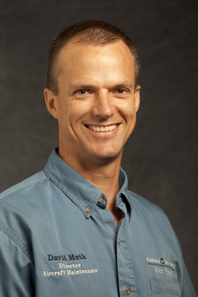

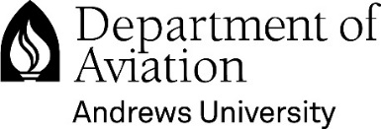
Farewell Reception
for David Muth

Date: Tuesday May 2nd, 2017
Time: 3 – 6 p.m.
Location: Simulator Building, Andrews Airpark

On behalf of the Department of Aviation, please join us for a farewell reception to honor David Muth for his service to Andrews University. David began his career in Aviation Maintenance in 1986 after graduating from Colorado Aero Tech. Since that time, David has served in every major part of the fixed wing aircraft maintenance industry during his diversified thirty-one year career. When David accepted employment with Andrews University in 2010, he served as a Federal Aviation Administration Accountable Manager for Andrews University Airpark, FAA Part 145 certified repair station. In 2015 David became an Associate Professor for Aviation Maintenance here at Andrews University.
David and his family plan to relocate to Washington state to be close to their grown children and granddaughter, and many other family and friends. David is excited to be returning to work as an APIA for a General Aviation aircraft maintenance facility based in Tri-cities Washington.

This will be a come-and-go reception

