You Are Invited To A
Used Adventist Book Sale At
Village Adventist Elementary School
April 8 from 10am-4pm At
409 W Mars St, Berrien Springs, MI 49103

Used Adventist Book Sale Sunday, April 8, 10am-4pm. There will be about 7,000 used book for sale. If you are looking for something specific, John Segar is encouraging you to call him in advance at (269) 781-6379. Part of the proceeds will go to the Village Adventist Elementary School.

- We will have a large assortment of used Adventist books including:
  - Doctrinal
  - Ellen G. White books
  - Story books
  - Bible Story/Uncle Arthur Bedtime Story
  - SDA Bible Commentary
  - Song Books
  - Cook Books

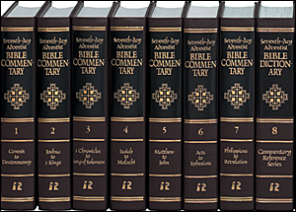
You Are Invited To A
Used Adventist Book Sale At
Village Adventist Elementary School
April 8 from 10am-4pm At
409 W Mars St, Berrien Springs, MI 49103

Used Adventist Book Sale Sunday, April 8, 10am-4pm. There will be about 7,000 used book for sale. If you are looking for something specific, John Segar is encouraging you to call him in advance at (269) 781-6379. Part of the proceeds will go to the Village Adventist Elementary School.

- We will have a large assortment of used Adventist books including:
  - Doctrinal
  - Ellen G. White books
  - Story books
  - Bible Story/Uncle Arthur Bedtime Story
  - SDA Bible Commentary
  - Song Books
  - Cook Books

