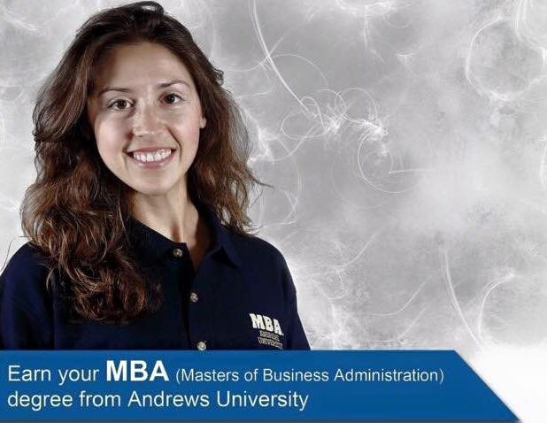

**Free MBA Information Seminar and GMAT Review Workshop**

**Strengthen Your Career with an MBA or MSA in Organizational Management!**

School of Business Administration **(SBA)** will be offering an **MBA information Seminar** and a free **GMAT (Graduate Management Admission Test)** for students who are interested in pursuing MBA degree.

**MBA Information Seminar (1/15/18) and GMAT (Graduate Management Admission Test) Review Workshop (1/22/18 - 2/12/18)**

**When:** Mondays, 1/15, 1/22, 1/29, 2/5 and 2/12, 6:30 p.m.-8:30 p.m.

**Where:** Chan Shun Hall, Room 208

**How:** RSVP by sending e-mail to [naoko@andrews.edu](mailto:naoko@andrews.edu) by 1/20/2018. Please bring your personal check with amount of $20 as the registration fee, you will be given the GMAT Review Book for five class period. If you do not miss any of classes, your $20 personal check will be refunded.

**Curriculum and Instruction:**

1/15 MBA Information Seminar

1/22 GMAT Review Workshop (Critical Reasoning and Problem Solving)

1/29 GMAT Review Workshop (Sentence Correction, Data Sufficiency and Problem Solving)

2/5  GMAT Review Workshop (Integrated Reasoning)

2/12 GMAT Review Workshop (Reading Comprehension and Essay Writings)

# *For any further information, please contact Dr. Jerry Chi at* [*jerry@andrews.edu*](mailto:jerry@andrews.edu)*, Naoko Jacobson at* [*naoko@andrews.edu*](mailto:naoko@andrews.edu)*, or Justin Neu at* [*neu@andrews.edu*](mailto:neu@andrews.edu)

Online attendance available. If you are staying far away from Andrews campus, or you need to miss one class period, you may use this video conference link <https://andrews.zoom.us/j/983325322> for watching the real time video presentation or contact Naoko for the video recording. It will be counted as the attendance.

cid:image015.jpg@01CF74E5.6F239750

**“Seek Knowledge. Affirm Faith. Change the World.”**