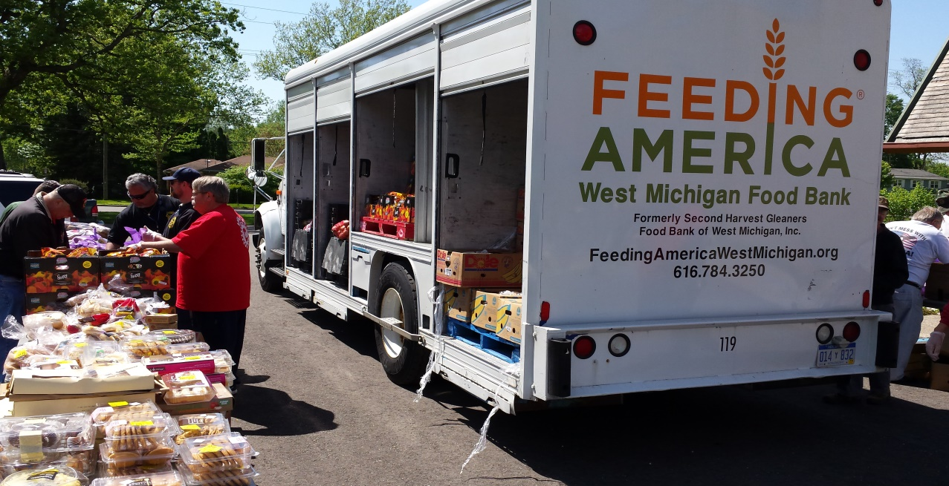
Feeding America Mobile Pantry
Coming to a parking lot near you.
Neighbor To Neighbor
9147 US 31, Berrien Springs, MI
Thursday, April 19, 2018 4PM – 6PM

