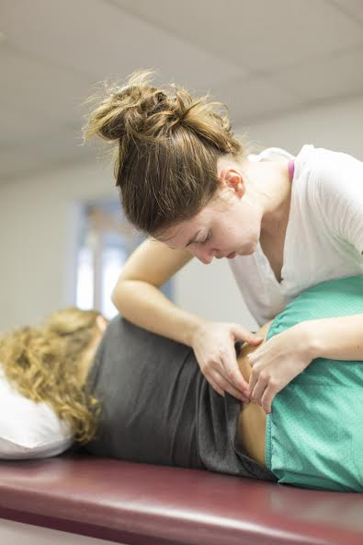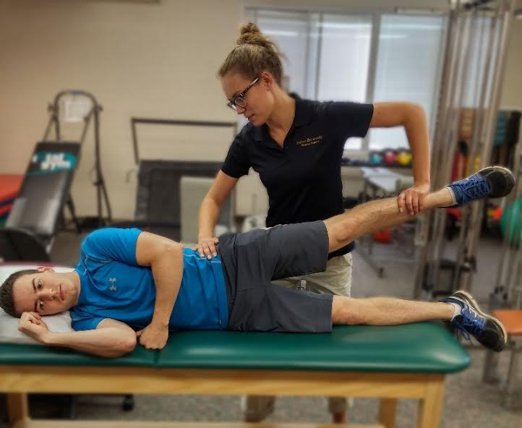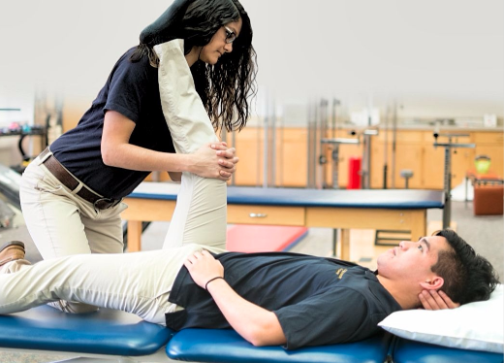

Email ptserviceclinic@gmail.com to schedule your appointment

10am-5pm

All ages and all physical injuries can get a FREE examination by student physical therapists along with supervising licensed physical therapists. Appointments are encouraged due to limited walk in availability.

8515 East Campus Circle Drive Berrien Springs, MI 49103

PHYSICAL THERAPY SERVICE CLINIC

# Andrews University Dept. of Physical Therapy

## Sunday November 4th, 2018