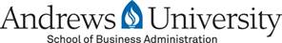

Free ONLINE GMAT Review Workshop
Strengthen Your Career with a MBA!

Andrews University College of Professions (CP) will be offering a free GMAT (Graduate Management Admission Test for MBA Program) workshop and MBA/MSA Management Information Seminar in September and October of 2020. This five-week seminar will be held ONLINE and sponsored by Andrews University, College of Professions, 4185 E. Campus Circle Dr., Berrien Springs, MI 49104-0020. RSVP is required.

Join Zoom Meeting
https://andrews.zoom.us/j/3147444957
Meeting ID: 314 744 4957

- Monday 9/14 6:30-8:30 p.m. MBA Information Seminar and GMAT Introduction
- Monday 9/21 6:30-8:30 p.m. GMAT Review Workshop
- Monday 9/28, 6:30-8:30 p.m. GMAT Review Workshop
- Monday 10/5, 6:30-8:30 p.m. GMAT Review Workshop
- Monday 10/12 6:30-8:30 p.m. GMAT Review Workshop

Registration

- The workshop will be administered by Dr. Jerry Chi, MBA, Ph.D., Ph.D.
- To register RSVP, attendees must RSVP to Mrs. Naoko Jacobson, naoko@andrews.edu

This GMAT workshop will be using the KAPLAN GMAT Premier Program for the class instruction. Both versions have similar questions.

Kaplan GMAT 2008 Premier Program (Recommended to buy now)
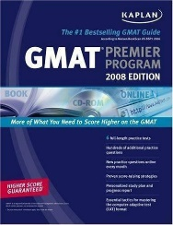
Price: $6.49 eBay.com
ISBN-10 | 1419551310
ISBN-13 | 9781419551314
OR,

GMAT Prep Plus 2019
ISBN-13: 978-1506234892
ISBN-10: 1506234895
Price: $44.99 Amazon.com (Can use it for further review)
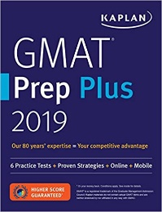

You may consider joining our vibrant MBA learning community comprised of innovative educators, active scholars, passionate students and a dedicated staff of professionals. During economic downturn and COVID-19, MBA has been highly recommended as a life-changing and recession-proof managerial leadership degree.
Currently we offer two graduate business degrees
- On-Campus/Online MBA Program: NEED GMAT SCORE FOR THIS BUSIENSS MASTER DEGREE (GMAT score + GPA x200=1000 points)
- Finance (You can add CPA courses to the Finance Concentration)
- Healthcare/Hospital Management Concentration
- General Management Concentration

https://www.andrews.edu/grad/programs/cp/mba.html
(Click Here for Application)

- On-Campus/Online MSA (Master of Science Administration): Organizational Management Concentration (Human Resource Management, Supply-Chain Management, Marketing Management) - DO NOT NEED GMAT SCORE FOR THIS BUSIENSS MASTER DEGREE.
https://www.andrews.edu/grad/programs/cp/msa.html (Click Here for Application)
Should you have any questions or needs for help, please do not hesitate to contact me at any time.

Wish you all the best and God bless,

Jerry Chi

Dr. Jerry Chi, MBA, Ph.D. , PhD.
Assistant Dean
MBA/MSA Graduate Program Director
Professor of Management
School of Business Administration
Andrews University
817-648-5416
