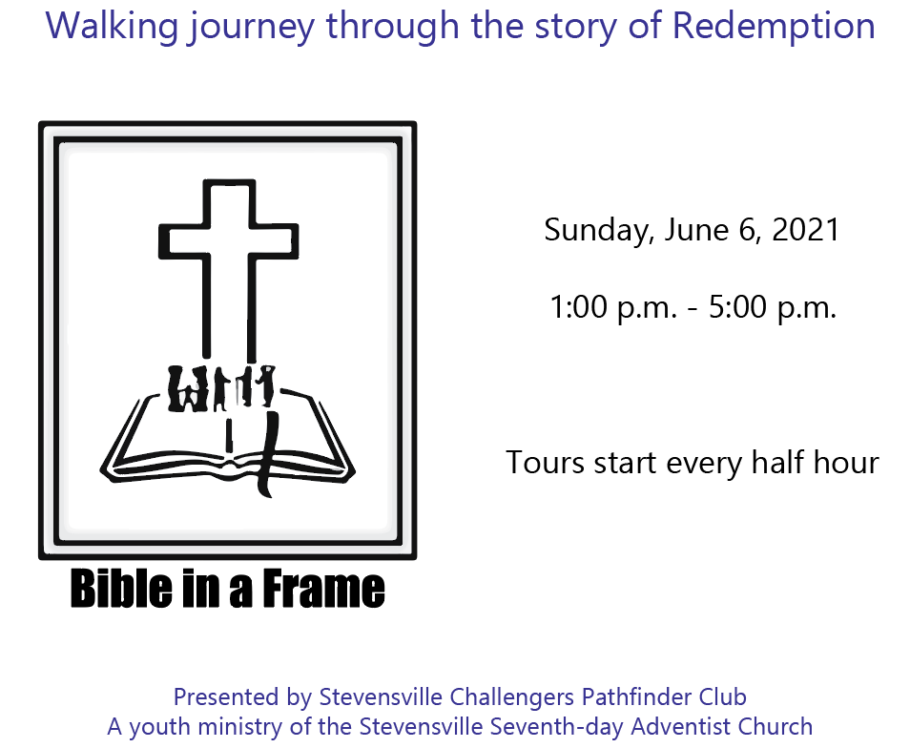

6657 Stevensville-Baroda Road  
Stevensville Michigan