Follower Styles Described by Ira Chaleff (The Courageous Follower)
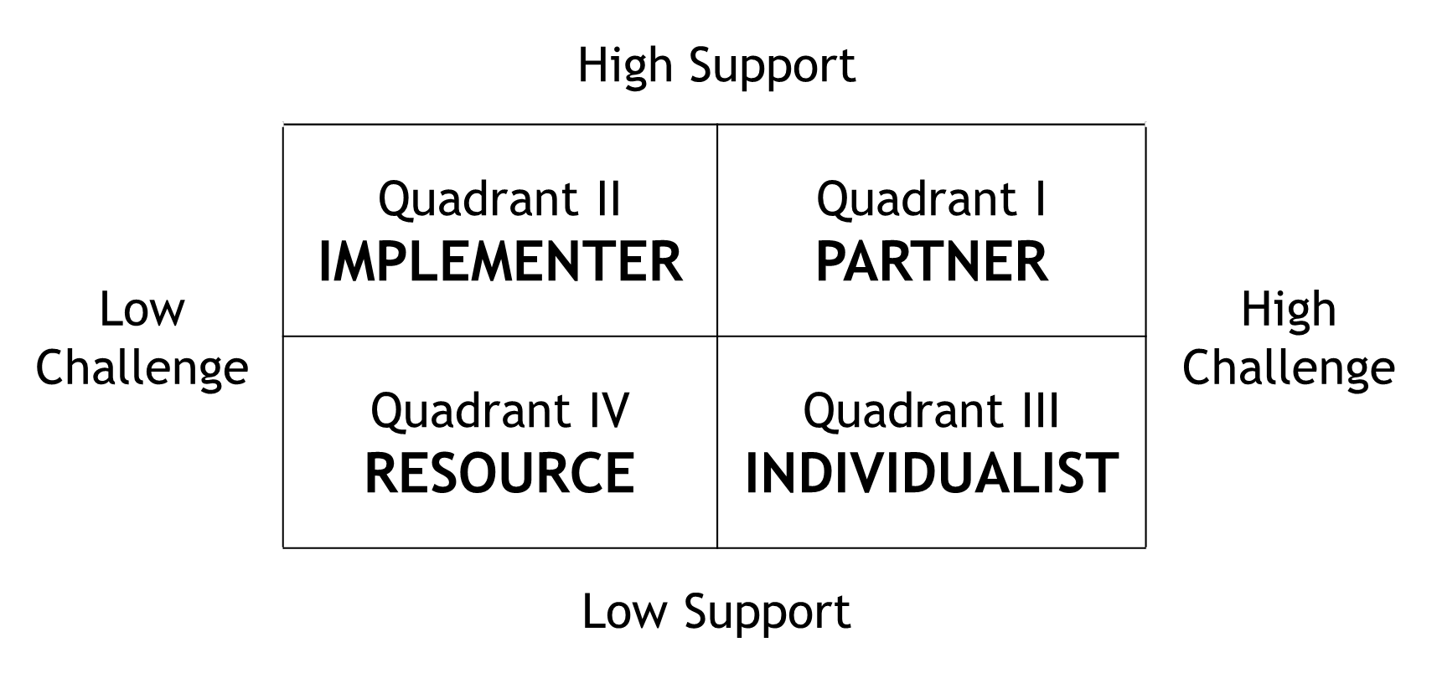
- Quadrant IV: Low Support, Low Challenge - RESOURCE
  - Satisfactory worker, but not beyond minimum expectations
- Quadrant III: Low Support, High Challenge – INDIVIDUALIST
  - Speaks out freely – maybe too freely; doesn’t support leader with high energy
- Quadrant II: High Support, Low Challenge – IMPLEMENTER
  - Works hard without much oversight; won’t challenge leader or policy
- Quadrant I: High Support, High Challenge – PARTNER
  - Willing to challenge leader’s actions when necessary; highly supportive of leader
Follower Styles with Attributes
Implementer  Dependable  Supportive  Considerate  Advocate  Defender  Team Oriented  Compliant  Respectful of authority  Reinforces leader’s perspectives | Partner  Purpose driven  Mission oriented  Risk taker  Cultivates relationships  Holds self and others accountable  Confronts sensitive issues  Focuses on strengths and growth  Peer relations with authority  Complements leader’s perspectives
Resource  Present  Available  Extra pair of hands  Brings specific skills  Uncommitted  Primary interests lie elsewhere  Executes minimum requirements  Makes complaints to third parties  Avoids attention of authority | Individualist  Confrontational  Forthright  Self-assured  Independent thinker  Reality checker  Irreverent  Rebellious  Self-marginalizing  Unintimidated by authority

Beyond “Lead, Follow, or Get Out of the Way” Kevin Wiley

