Assignment 1
Problem 1
A two-way factorial ANOVA was performed using SPSS to assess whether the time that fathers spent playing with their children could be predicted from the disability status of the child (A1 = normal, A2 = physically disabled, A3 = mentally retarded), the gender of the child (B1 = male, B2 = female), and the interaction between the disability status and the gender of the child.
Preliminary data screening was done to assess whether the assumptions for ANOVA were seriously violated. Examination of the outcome variable revealed that the performance score was mildly skewed (0.320) and the Levene test indicated no significant violation of the homogeneity of variance assumption (p = 0.546).
There were a total of 60 father-child dyads in six categories. The means and standard deviations of the time (in minutes) that fathers spent playing with their children are outlined in Table 1, below. Due to the unequal cell sizes in the mental retardation group, the weighted marginal means are reported. From this table, it is evident that the fathers with normal, male children spent the most time playing with their children (mean = 7.30 minutes), whereas the fathers with mentally retarded, male children spent the least time playing with their children (mean = 2.89 minutes). Regardless of disability status, fathers spent more time (mean = 5.76) playing with their male children than with their female children (mean = 4.32). If the gender of the child is disregarded, fathers spent the most time playing with their normal children (mean = 5.60) and the least time with their mentally retarded children (mean = 4.15).

Table 1

Play Time Means and Standard Deviations
-------------------------------------------------------------------------------------------------------------------------------
Disability Gender Mean SD N
Status
-------------------------------------------------------------------------------------------------------------------------------
Normal Male 7.30 1.829 10
Female 3.90 1.370 10
Total 5.60 2.349 20

Physical Disability Male 6.80 2.201 10
Female 3.80 1.476 10
Total 5.30 2.386 20

Mental Retardation Male 2.89 2.028 9
Female 5.18 1.888 11
Total 4.15 2.231 20

Total Male 5.76 2.773 29
Female 4.32 1.681 31
Total 5.02 2.369 60
-------------------------------------------------------------------------------------------------------------------------------

From the two-way ANOVA (see Table 2, below), we can make the following conclusions. The first main effect, i.e., disability status, was statistically significant (FA (2, 54) = 4.140, p = .021, with an associated effect size of partial eta squared = .133). Furthermore, from the Student-Newman-Keuls test we can conclude that the mean for normal children (5.60) was significantly higher than the mean for mentally retarded children (4.15); however, the mean for children with a physical disability (5.30) was not significantly different from the mean for normal children, nor from the mean for mentally retarded children. The second main effect, i.e., gender, was also statistically significant (FB (1, 54) = 8.466, p = .005, with an associated effect size estimate of 0.136), i.e., the mean for male children was significantly higher than the mean for female children. There was also a statistically significant disability status by gender interaction effect (FA*B (2,54) = 15.153, p = .000). The corresponding effect size estimate of 0.359 indicated a very large effect.

Table 2
Two-way ANOVA
-------------------------------------------------------------------------------------------------------------------------------
Source SS df MS F p Partial Eta
Squared
-------------------------------------------------------------------------------------------------------------------------------
Disability
Status (A) 27.405 2 13.702 4.140 .021 .133

Gender (B) 28.019 1 28.019 8.466 .005 .136

Interaction (A*B) 100.302 2 50.151 15.153 .000 .359

Error 178.725 54 3.310

(Corrected) Total 330.983 59
-------------------------------------------------------------------------------------------------------------------------------

From the follow-up analysis, i.e., the test of simple effects as well as the post hoc pairwise comparison using the Bonferroni procedure, we can draw several conclusions. First, from the test of simple effects (see Table 3, below), it is evident that there were statistically significant differences (F(2,54) = 16.425, p = .000, with an associated effect size estimate of 0.378) in the means of the three different types of disabilities for male children. Furthermore, from the pairwise comparison, we can see that the mean score for the mentally retarded male children was significantly lower than for both normal and physically retarded male children; whereas the difference between the mean scores for normal and physically handicapped male children was not significant (see Table 4, below, for the pairwise comparison of disability at male gender). Second, from the test of simple effects, it is evident that there were no statistically significant differences in the means of the three types of disabilities for female children (see Table 3, below). See also Figure 1, below, for a plot of marginal means of time (in minutes) for disability at gender.
Third, from the test of simple effects, it is also evident that there were statistically significant differences in the means for gender at disability, i.e., first, fathers spent significantly (F(1, 54) = 17.464, p = .000, effect size = .244) more time playing with their normal male children than with their normal female children; second, fathers spent significantly (F(1, 54) = 13.596, p = .001, effect size = .201) more time playing with their physically disabled, male children than with their physically disabled, female children; and third, fathers spent significantly (F(1, 54) = 7.863, p = .007, effect size = .127) less time playing with their mentally retarded, male children than with their mentally retarded, female children. See Table 3, as well as Figure 2, for details.

Table 3
Test of Simple Effects ANOVA
-------------------------------------------------------------------------------------------------------------------------------
Source SS df MS F p Partial Eta
Squared
-------------------------------------------------------------------------------------------------------------------------------
Disability
Disability at male 108.721 2 54.361 16.425 .000 .378

Disability at female 12.638 2 6.319 1.909 .158 .066
Gender
Gender at normal 57.800 1 57.800 17.464 .000 .244
Gender at physical
disability 45.000 1 45.000 13.596 .001 .201
Gender at mental
retardation 26.025 1 26.025 7.863 .007 .127

Error 178.725 54 3.310
-------------------------------------------------------------------------------------------------------------------------------

Table 4
Pairwise Comparison for Disability at Male Gender
-------------------------------------------------------------------------------------------------------------------------------
Disability Status N Mean SD Disability Status
2 3
----------------------------------------------------------------------------------------------------------------
1. Normal 10 7.30 1.829 *
2. Physically Disabled 10 6.80 2.201
3. Mentally Retarded 9 2.89 2.028
-------------------------------------------------------------------------------------------------------------------------------
*indicates statistically significant mean difference, p < 0.01
------------------------------------------------------------------------

Figure 1
Estimated Marginal Means of Time for Disability at Gender
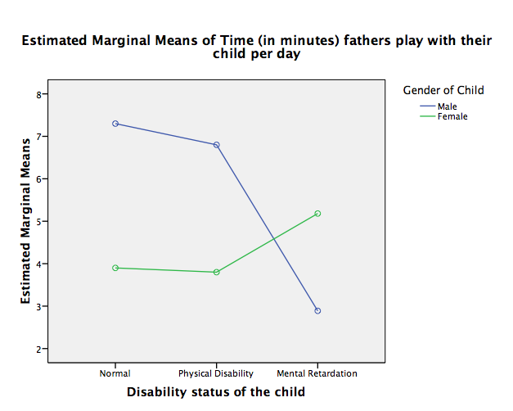

Figure 2
Estimated Marginal Means of Time for Gender at Disability
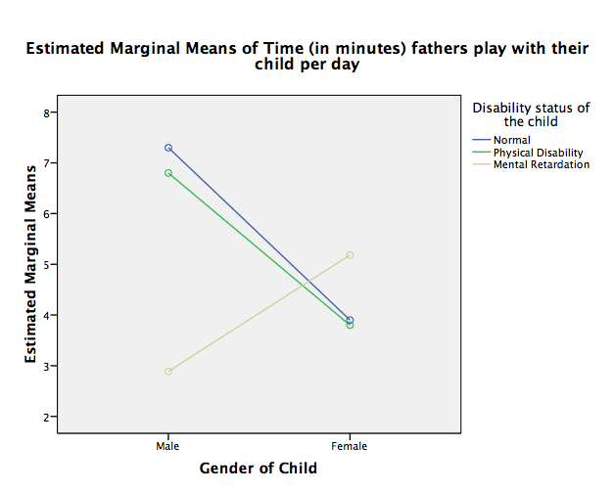
Thus, in conclusion, although there were both large and statistically significant main effects, there was also a statistically significant and extremely large interaction effect.

Problem 2
A two-way factorial ANOVA was performed using SPSS to assess whether arithmetic problem-solving performance of 2nd grade students could be predicted from the type of reinforcer (A1 = token, A2 = money, A3 = food), the type of reinforcement schedule (B1 = random, B2 = spaced), and the interaction between the type of reinforcer and the reinforcement schedule. This was an orthogonal factorial design; each of the six cells had the same number of participants (n = 11).
Preliminary data screening was done to assess whether the assumptions for ANOVA were seriously violated. Examination of the outcome variable revealed that the performance score was only minimally skewed (- 0.250) and the Levene test indicated no significant violation of the homogeneity of variance assumption (p = 0.196).
Arithmetic problem-solving test score means and standard deviations are outlined in Table 1, below. From this table it is evident that the group with a spaced reinforcement schedule and money as reinforcement type had the highest mean score (37.00), whereas the group with a random reinforcement schedule and a token reinforcement type had the lowest mean score (19.64). Regardless of the type of reinforcer used, the mean score for children with a spaced schedule (31.91) was higher than the mean score for children with a random schedule (26.45). If the type of reinforcement schedule is disregarded, the mean score for children whose learning was reinforced with money was the highest (32.64), whereas the mean score for children who received a token reinforcer was the lowest (23.05).

Table 1
Test Score Means and Standard Deviations
---------------------------------------------------------------------------------------------
Reinfor Schedule Mean SD N
---------------------------------------------------------------------------------------------
Token random 19.64 5.025 11
spaced 26.45 4.009 11
Total 23.05 5.644 22

Money random 28.27 4.756 11
spaced 37.00 4.313 11
Total 32.64 6.291 22

Food random 31.45 5.279 11
spaced 32.27 2.687 11
Total 31.86 4.109 22

Total random 26.45 7.027 33
spaced 31.91 5.681 33
Total 29.18 6.910 66
---------------------------------------------------------------------------------------------

From the two-way ANOVA (see Table 2, below), we can make several conclusions. The first main effect, i.e., reinforcement type, was statistically significant (FA(2, 60) = 31.857, p = .000, with an associated effect size estimate of 0.515), i.e., the mean score for the token reinforcement group (23.05) was significantly lower than the mean score for the money reinforcement group (32.64); furthermore, the Student-Newman-Keuls test revealed that the mean score for the food reinforcement group (31.86) was significantly higher than the token reinforcement group, but not significantly lower than the money reinforcement group. The second main effect, i.e., the schedule type, was also statistically significant (FB (1, 60) = 25.039, p = .000, with an estimated effect size of 0.294), i.e., the mean score for the random reinforcement schedule group (26.45) was significantly lower than the mean score for the spaced reinforcement schedule group (31.91). There was also a statistically significant type of reinforcer by reinforcement schedule interaction effect (FA*B(2,60) = 4.778, p = 0.012). The corresponding effect size estimate of 0.14 indicated a large effect.

Table 2
Two-way ANOVA
-------------------------------------------------------------------------------------------------------------------------
Source SS df MS F p Partial Eta
Squared
--------------------------------------------------------------------------------------------------------------------------
Reinforcer (A) 1249.182 2 624.591 31.857 .000 .515
Schedule (B) 490.909 490.909 25.039 .000 .294
Interaction (A*B) 187.364 2 93.682 4.778 .012 .137
Error 1176.364 60 19.606
Total 3103.818
---------------------------------------------------------------------------------------------------------------------------

From the follow-up analysis, i.e., the test of simple effects as well as the post hoc pairwise comparison using the Bonferroni procedure (see Tables 3 and 4, below), we can draw several conclusions. First, from the test of simple effects, it is evident that there were significant differences (F(2,60) = 20.981, p = .000, with an estimated effect size of 0.412) in mean test scores for the three different types of reinforcers in the random schedule group. Furthermore, from the pairwise comparison, we can see that the mean score for the token reinforcer group was significantly lower (p = .000) than the mean score for both the food and money groups; however, the difference between the food and money groups was not significant (p = 0.291). Second, from the test of simple effects, it is evident that there were significant differences (F(2,60) = 15.654, p = .000, with an effect size of 0.343) in mean test scores for the three different types of reinforcers in the spaced schedule group. Furthermore, from the pairwise comparison, we can see that the mean score for the token group was significantly lower than the mean score for the money group (p = .000) and the food group (p= .009); and the food group was significantly lower than the money group (p = .045). See also Figure 1, below, for a plot of marginal means of test scores for reinforcer at schedule.
Third, in the token reinforcer group, the mean score for the spaced schedule group was significantly higher than the mean score for the random schedule group (F(1,60) = 13.041, p = .001, with an estimated effect size of 0.179). Fourth, in the money reinforcer group, the mean score for the spaced schedule group was significantly higher than the mean score for the random schedule group (F(1, 60) = 21.366, p = .000, with an estimated effect size of 0.263). There was no statistically significant difference between the random and the scheduled groups when food was used as a reinforcer. See also Figure 2, below, for a plot of marginal means of test score for schedule at reinforcer.

Table 3
Test of Simple Effects ANOVA
--------------------------------------------------------------------------------------------------------------------------
Source SS df MS F p Partial Eta
Squared
---------------------------------------------------------------------------------------------------------------------------
Reinforcer
Reinfor at random 822.727 2 411.364 20.981 .000 .412
Reinfor at spaced 613.818 2 306.909 15.654 .000 .343
Schedule
Schedule at token 255.682 1 255.682 13.041 .001 .179
Schedule at money 418.909 1 418.909 21.366 .000 .263
Schedule at food 3.682 1 3.682 .188 .666 .003
Error 1176.364 60 19.606
-----------------------------------------------------------------------------------------------------------------------------

Table 4
Pairwise Comparison of Test Score Means
---------------------------------------------------------------------------------------------------------------
Schedule Reinfor N Mean SD Reinfor
Money Food
---------------------------------------------------------------------------------------------------------------
Random Token 11 19.64 5.025 * *
Money 11 28.27 4.756 *
Food 11 31.45 5.279
---------------------------------------------------------------------------------------------------------------
Spaced Token 11 26.45 4.009 * *
Money 11 37.00 4.313 *
Food 11 32.27 2.687
----------------------------------------------------------------------------------------------------------------
* indicates statistically significant mean difference, p < .05
-----------------------------------------------------------------------

Figure 1
Estimated Marginal Means of Test Scores for Reinforcer at Schedule
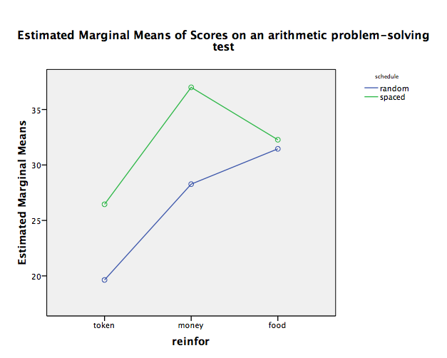
Figure 2
Estimated Marginal Means of Test Scores for Schedule at Reinforcer
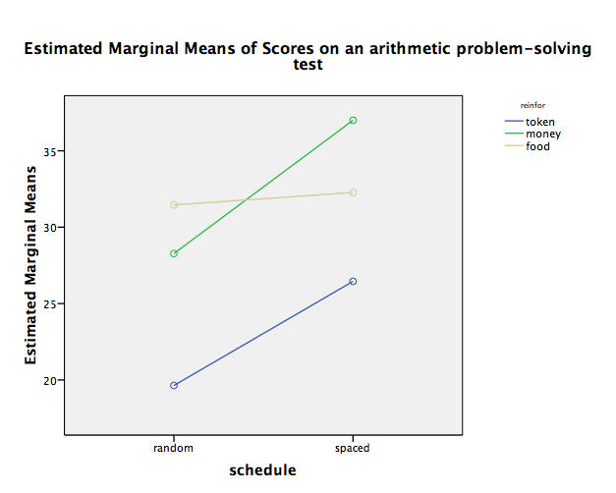

Thus, in conclusion, the main effects were both large and statistically significant; however, there was also a statistically significant and large interaction effect.

