Assignment 2
Problem 1
(a) The null hypothesis is that there is no difference in blood stream drug concentration means between the six different times.
(c) effect size (partial eta squared) = SS(between treatments) / SS(between treatments) + SS(error)
= 24866 / 24866 + 794
= 0.969

(d)
To evaluate whether the concentration of a single dose of drug in the blood stream changes over time, a one-way repeated measures ANOVA was performed. Blood samples of five participants were analysed for concentration of the drug, at six different times: (1) just prior to the assigned dose, (2) a half hour after the dosing, (3) one hour after the dosing, (4) two hours after the dosing, (5) three hours after the dosing, and (6) four hours after the dosing.
The means and standard deviations of the drug concentrations (in mg/ml) are outlined in Table 1, below. There is a statistically significant (p = .001) linear trend in the change in blood stream drug concentration means (in mg/ml) over time (see Figure 1, below).

Table 1
Drug Concentration Means and Standard Deviations
-------------------------------------------------------------------------------------------------------------------------------
Time Mean SD N
-------------------------------------------------------------------------------------------------------------------------------
1. Prior to dosing .000 .000 5
2. Half hour after dosing 55.00 11.180 5
3. One hour after dosing 81.00 6.519 5
4. Two hours after dosing 134.00 11.937 5
5. Three hours after dosing 80.00 14.577 5
6. Four hours after dosing 42.00 8.3666 5
-------------------------------------------------------------------------------------------------------------------------------

Because the mean at Time 1 was .000, a paired samples t-test was done to determine if the mean at Time 1 was significantly different from the mean at Time 6, which was the lowest ‘after dosing’ mean (42.00). This was found to be significant (p = .000). Time 1 was then excluded from subsequent analysis. Preliminary data screening was done to assess whether the assumptions for one-way repeated measures ANOVA were seriously violated. Examination of the mean scores at times 2 through 6 revealed skewness ranging from 0.541 to – 0.605. The Mauchly test was also performed to assess for possible violation of the sphericity assumption; this was not significant (Mauchley’s W = .001, p = .105).
A one-way repeated measures ANOVA (see Table 2, below) revealed that overall F for differences in mean drug concentration across the five different times (i.e., time 2 through time 6) was statistically significant: F(4, 16) = 125.270, p = .000, with a corresponding effect size of partial eta squared = .969. In other words, 96.9% of the variance in blood stream drug concentration was related to the different treatment conditions (or time related to dosing).

Table 2
One-way Repeated Measures ANOVA
-------------------------------------------------------------------------------------------------------------------------------
Source SS df MS F p Partial Eta
Squared
-------------------------------------------------------------------------------------------------------------------------------
Between Treatments 24866.000 4 6216.500 125.270 .000 .969
Between Subjects 1576.000 4 394.000
Error 794.000 16 49.625
-------------------------------------------------------------------------------------------------------------------------------
From the follow-up analysis, i.e., the post hoc pairwise comparison using the Bonferroni procedure, we can draw several conclusions; first, the mean drug concentration prior to dosing was significantly lower than all ‘after dosing’ times; second, the mean drug concentration half an hour after dosing was significantly lower than one, two, and three hours after dosing; third, the mean drug concentration one hour after dosing was significantly lower than two hours after dosing, and significantly higher than four hours after dosing; fourth, the mean drug concentration two hours after dosing was significantly higher than all other times; and fifth, the mean drug concentration three hours after dosing was significantly higher than four hours after dosing. See Table 3 for a summary of the pairwise comparison test, as well as Figure 1 for a plot of marginal means of drug concentration at time.

Table 3
Pairwise Comparison of Mean Drug Concentration at Time
-------------------------------------------------------------------------------------------------------------------------------
Time N Mean SD Time
2 3 4 5 6
-------------------------------------------------------------------------------------------------------------------------------
1.Prior to dosing 5 .000 .000 * * * * *
2.Half hour after dosing 5 55.00 11.180 * * *
3.One hour after dosing 5 81.00 6.519 * *
4.Two hours after dosing 5 134.00 11.937 * *
5.Three hours after dosing 5 80.00 14.577 *
6.Four hours after dosing 5 42.00 8.3666
-------------------------------------------------------------------------------------------------------------------------------
* statistically significant mean difference, p < .05 after adjustment for multiple comparison procedures (Bonferroni).

Figure 1
Estimated Marginal Means of Drug Concentration at Time
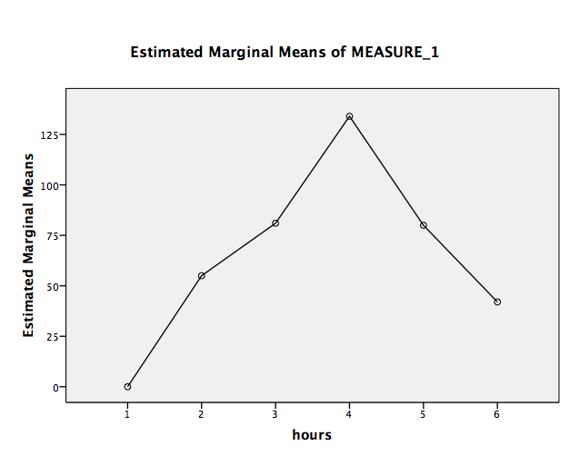

Problem 2.
To evaluate whether men change in their level of expression of worry during their marriage, a one-way repeated measures ANOVA was performed. Thirty male participants completed the Desire to Express Worry Scale (DEW) at four different times: (1) when they were initially married, (2) at their fifth anniversary, (3) at their tenth anniversary, and (4) at their fifteenth anniversary.
The means and standard deviations of the DEW scores are outlined in Table 1, below. There is a statistically significant (p = .002) linear trend in the change in mean DEW scores over time (see Figure 1, below).

Table 1
Desire to Express Worry (DEW) Score Means and Standard Deviations
-------------------------------------------------------------------------------------------------------------------------------
Years of Marriage Mean SD N
-------------------------------------------------------------------------------------------------------------------------------
Initially married 65.80 9.227 30
5 years after marriage 65.43 10.686 30
10 years after marriage 63.10 10.685 30
15 years after marriage 61.93 12.567 30
-------------------------------------------------------------------------------------------------------------------------------

Preliminary data screening was done to assess whether the assumptions for one-way repeated measures ANOVA were seriously violated. Examination of the mean scores at times1 through 4 revealed skewness ranging from -0.335 to 0.456. The Mauchly test of sphericity was performed to assess for possible violation of the sphericity assumption. This was significant, (Mauchly’s W = .483, p = .001); thus, the Huyn-Feldt correction was made to the degrees of freedom used to evaluate the significance of the F ratio.
A one-way repeated measures ANOVA (see Table 2, below) revealed that overall F for differences in mean DEW scores across the four different times was statistically significant: F(2,66) = 7.664, p = .001, with a corresponding effect size of partial eta squared = .209. In other words, 20.9% of the variance in the DEW score was related to the time the participants had been married.

Table 2
One-way Repeated Measures ANOVA
-------------------------------------------------------------------------------------------------------------------------------
Source SS df MS F p Partial Eta
Squared
-------------------------------------------------------------------------------------------------------------------------------
Between Treatments 310.733 2.260 137.483 7.664 .001 .209
Between Subjects 12494.967 29 430.861
Error 1175.767 65.545 17.938
-------------------------------------------------------------------------------------------------------------------------------

From the follow-up analysis, i.e., the post hoc pairwise comparison using the Bonferroni procedure, we can draw several conclusions; first, the mean DEW score at the time of marriage was not significantly different from the DEW score at the 5th anniversary; second, the mean DEW score when the men were initially married was significantly higher than at the 10th and 15th anniversaries; third, the mean DEW score at the 5th anniversary was significantly higher than at the 10 and 15th anniversaries; and fourth, the mean DEW score at the 10th anniversary was not significantly different from the DEW score at the 15th anniversary. See Table 3 for a summary of the pairwise comparison test, as well as Figure 1 for a plot of marginal means of DEW scores at time.

Table 3
Pairwise Comparison of Mean DEW Scores at Years of Marriage
-------------------------------------------------------------------------------------------------------------------------------
Years of marriage N Mean SD Years of Marriage
1 2 3 4
-------------------------------------------------------------------------------------------------------------------------------
1. Initially married 30 65.80 9.227 * *
2. 5 years after marriage 30 65.43 10.686 * *
3. 10 years after marriage 30 63.10 10.685
4. 15 years after marriage 30 61.93 12.567
-------------------------------------------------------------------------------------------------------------------------------
*statistically significant mean difference, p < .05 after adjustment for multiple comparison procedures (Bonferroni).

Figure 1
Estimated Marginal Means of DEW Scores at Time
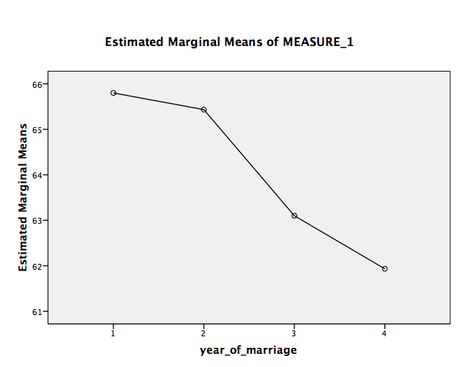

In summary, therefore, men who were initially married or married for five years were more likely to express worry to their spouse than they were at their 10th and 15th wedding anniversaries.

Problem 3.
Thirty music students who presented musical pieces over four consecutive occasions completed a nervousness scale to assess their levels of nervousness at each occasion. A one-way repeated measures ANOVA was performed to test the research hypothesis that nervousness decreases as one presents more often.
The means and standard deviations of the nervousness scores are outlined in Table 1, below. There is a statistically significant (p = .000) linear trend in the change in mean nervousness scores over time (see Figure 1, below).

Table 1
Nervousness Score Means and Standard Deviations
-------------------------------------------------------------------------------------------------------------------------------
Time Mean SD N
-------------------------------------------------------------------------------------------------------------------------------
1. First presentation 6.533 0.914 30
2. Second presentation 6.557 1.011 30
3. Third presentation 6.263 1.048 30
4. Fourth presentation 6.050 1.056 30
-------------------------------------------------------------------------------------------------------------------------------

Preliminary data screening was done to assess whether the assumptions for one-way repeated measures ANOVA were seriously violated. Examination of the mean scores at times 1 through 4 revealed skewness ranging from -0.270 to 0.432. The Mauchly test of sphericity was performed to assess for possible violation of the sphericity assumption. This was not significant (Mauchly’s W = .879, p = .610).
A one-way repeated measures ANOVA (see Table 2, below) revealed that overall F for differences in mean nervousness scores across the four different times was statistically significant: F(3,87) = 13.034, p = .000, with a corresponding effect size of partial eta squared = .310. In other words, 31% of the variance in the nervousness score was related to the number of times the participants had performed.

Table 2
One-way Repeated Measures ANOVA
-------------------------------------------------------------------------------------------------------------------------------
Source SS df MS F p Partial Eta
Squared
-------------------------------------------------------------------------------------------------------------------------------
Between Treatments 5.215 3 1.738 13.034 .000 .310
Between Subjects 106.482 29 3.672
Error 11.603 87 .133
-------------------------------------------------------------------------------------------------------------------------------

From the follow-up analysis, i.e., the post hoc pairwise comparison using the Bonferroni procedure, we can draw several conclusions; first, there was no significant difference between the mean nervousness scores at the first and second presentations; second, the mean nervousness score at the first presentation was significantly higher than at the third and fourth presentations; third, the mean nervousness score at the second presentation was also significantly higher than at the third and fourth presentations; and fourth, there was no significant difference between the mean nervousness scores at the third and fourth presentations. See Table 3 for a summary of the pairwise comparison test, as well as Figure 1 for a plot of marginal means of nervousness scores at time.

Table 3
Pairwise Comparison of Mean Nervousness Scores at Time
-------------------------------------------------------------------------------------------------------------------------------
Time N Mean SD Time
2 3 4
-------------------------------------------------------------------------------------------------------------------------------
1. First presentation 30 6.533 0.914 * *
2. Second presentation 30 6.557 1.011 * *
3. Third presentation 30 6.263 1.048
4. Fourth presentation 30 6.050 1.056
-------------------------------------------------------------------------------------------------------------------------------
*statistically significant mean difference, p < .05 after adjustment for multiple comparison procedures (Bonferroni).

Figure 1
Estimated Marginal Means of Nervousness Score at Time
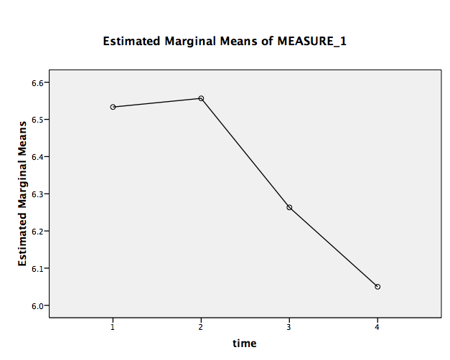
In summary, therefore, we can conclude that nervousness tends to decrease as one presents more often.

