# **Online Registration for Off-Campus Programs**

1. Visit [Andrews University](http://www.andrews.edu) website
2. Select the ‘CURRENT STUDENTS’ menu



* 1. Select ‘Registration Central’ from the drop menu



1. Provide your username and password – If this is your first time using Andrews University services you will want to activate your user name using the link ‘Create Account.’

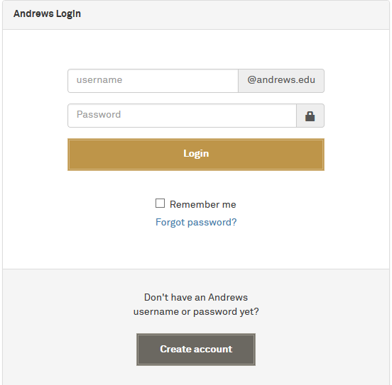

1. After you are logged in, select the semester for which you would like to enroll in classes from the drop box and click the ‘Next’ button:

Spring Term is January – April

Summer Term is May – July

Fall Term is August – December



1. The Registration Steps will display for the semester. Follow them in order, each step is dependent on the previous step. After each step is completed, a green checkmark ‘√’ will appear in front of the step.



* 1. ‘Biographical Data Confirmation’ – Please verify your biographical data and update as necessary. It is very important for reporting purposes that we have your most current information. Once you have updated your information select ‘next.’
  2. Enroll in Classes:
     1. If a ‘hold’ shows in your steps you will need to follow the instructions under contact information.
     2. Please notice that the following three sub-steps are necessary in order to complete registration.



* + 1. The first time you select ‘Enroll in Classes’ for the term you will be asked to verify your major and academic advisor information, then select yes and move to the ‘Class Registration’ page.

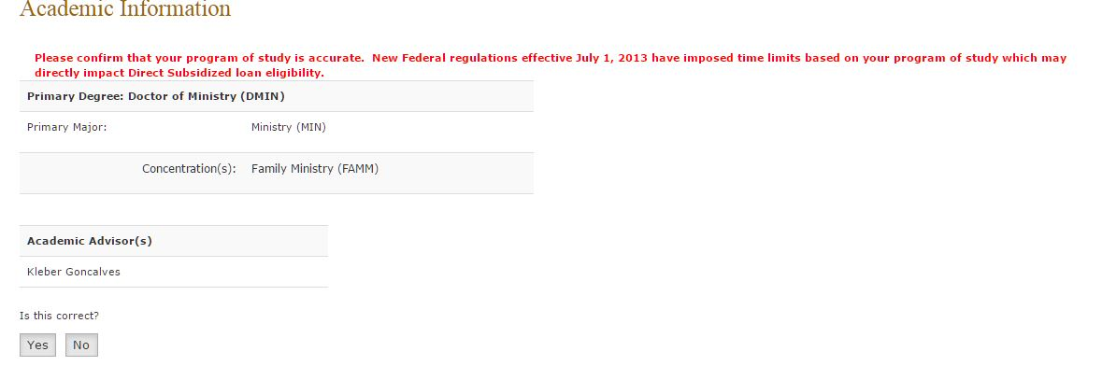

* + 1. If you are taking a self-paced course you will want to read the information and pay close attention to the *example* on the ‘Self-paced Course Information’ page.

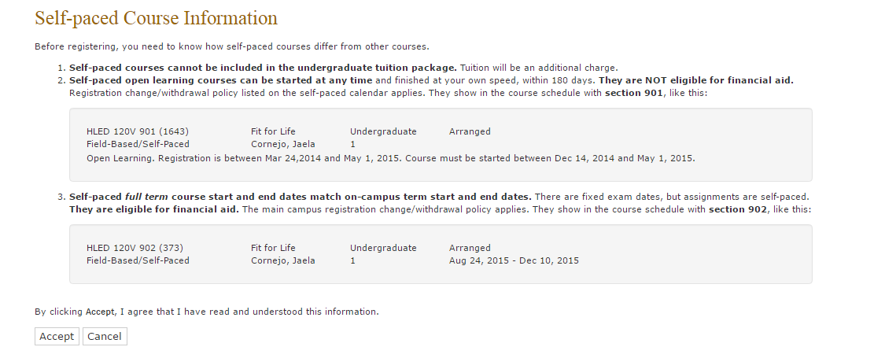

* + 1. Click the ‘accept’ button to go to the Class Registration page
    2. At the bottom of the ‘Class Registration’ page click the ‘Register online’ button *(you must have the pop-up windows enabled in your browser in order to proceed)*

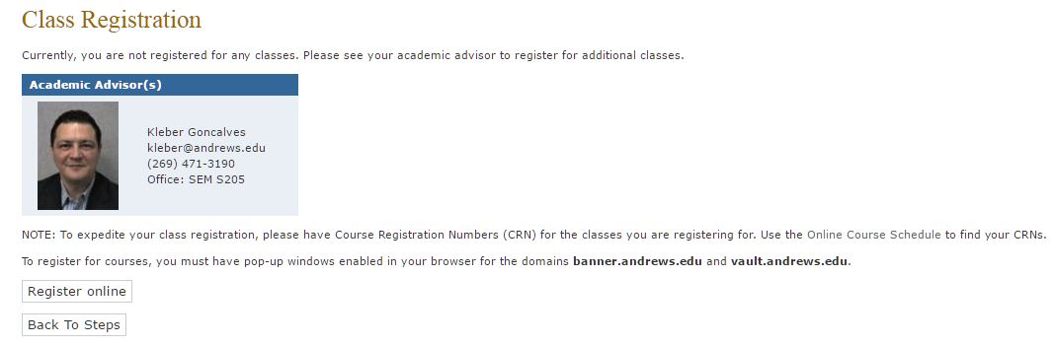

* + 1. If a pin number is required contact your academic advisor.
    2. Provide each CRN in the designated area for the classes in which you wish to enroll and click the ‘Submit Changes’ button.
       1. F*or a list of classes being offered at your location please follow instructions on the ‘Class Search’ menu at the bottom of the page or use the online course schedule* [*https://vault.andrews.edu/schedule/*](https://vault.andrews.edu/schedule/)*.*
       2. The CRN number can be found in the online course schedule as the numbers in parenthesis beside the course.

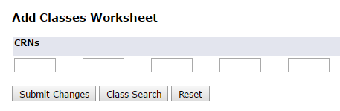

* + 1. Registration Start Date Confirmation
       1. Your start date will be pre-populated, select submit changes.

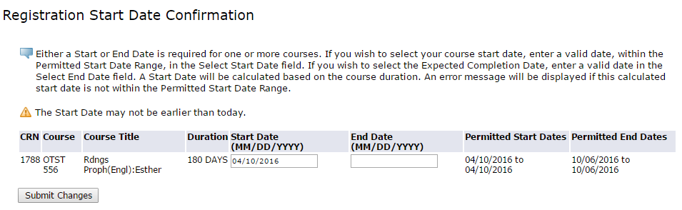

* + 1. You can verify that your courses have been registered because the status of the course will say ‘Web Registered.’

You are ready now to exit from the pop-up window that allows you to add or drop classes, (Add Classes Worksheet). Once back at the Class Registration page please select the ‘Back to Steps’ button

* 1. Financial Plan

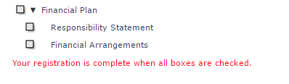

* + 1. Please complete each sub-step:
       1. Accept the ‘Responsibility Statement’ by entering your full name as it appears on the top-right corner of the screen, and by selecting the ‘Accept Statement’ button.
       2. Depending on the financial arrangement of your program, you might be done without any further action. If that is the case the ‘Financial Plan’ step will have a green checkmark ‘√’.
       3. If your program is sponsored *(paid in full or partially)* by a 3rd party, please make sure that your name has been provided to the Student Finance Services Office as a sponsored student.
       4. A payment of the difference might be required.