Website: https://www.acpe.edu/

Admission to the New Certification Process

Admission Competencies
It is the responsibility of the applicant to complete the “What is your evidence” column of the form in preparation for their interview.
- Admission Competencies Assessment Form

Process Overview
The ACPE Certification Process has two parts to the admission process:
Part One: Application and acceptance to a local ACPE Accredited Center
Part Two: Application and acceptance to become a Certified Educator Candidate with ACPE
Applicants begin the process by downloading and completing the Application for Certified Educator Programs from the ACPE website. The first page of the form should be completed and emailed to the local center and to the national office. Upon receipt, the national office will send the applicant information about setting up the portfolio to upload their responses to the questions on page two of the application.

Part One: The Local ACPE Accredited Center
Admission to the local ACPE Accredited Center includes the following criteria:
- A completed Application for Certified Educator Programs
- College graduation
- Graduate theological degree or its equivalent
- Ordination or commissioning to function as a spiritual care provider by an appropriate religious/spiritual authority as determined by ACPE. Individuals whose spiritual or religious community do not have ordination should email certification@acpe.edu for more information.
- Endorsement/statement of accountability from an appropriate religious/spiritual authority as determined by ACPE
- Successful completion of a minimum of four units of Level I/Level II CPE
- Demonstration of spiritual care and conceptual competence as evidenced by the attainment/completion of Level I/Level II Outcomes
- Evaluation of the competencies for admission to a Certified Educator Program
Using the application materials that applicants have uploaded to their portfolio, the ACPE Certified Educator will conduct an initial assessment of each applicant’s suitability for admission and potential for becoming an educator. Acceptance into the local program is distinct from acceptance to the ACPE Certification Process.
When a center has a single candidate and the ACPE Certified Educator has determined that the applicant meets the competencies for admission to the ACPE Certification Process, they will arrange for Part Two of the process to take place.

Part Two: The ACPE Certification Process
Once chosen by the local center, and prior to the ACPE interview, the applicant must view the following videos located on the New Certification Process webpage:
- Understanding Competencies
- Competencies for Admission
The applicant will write a brief reflection on each of the videos, demonstrating their understanding of the major ideas of each and include these reflections in their portfolio.
The training ACPE Certified Educator will arrange for the applicant’s interview. The interview committee will be comprised of three persons. The interview can be arranged in person or via video conference and will include the following persons:
- The training ACPE Certified Educator from the local center
- A representative of the Certification Commission who will be assigned by the Chair of the Commission or Certification Coordinator in the national office
- Another ACPE Certified Educator from outside of the center, who is part of the National Faculty (selected by the training ACPE Certified Educator).
The Certification Commission representative and the local ACPE Certified Educator shall be given access to the applicant’s portfolio no less than 30 days prior to the interview. Each will review the materials and evaluate the applicant in accordance with the competencies for admission.
If either the Commission Representative or the local ACPE Certified Educator determines that an applicant has not met the required competencies, they shall request a conference call with the ACPE Certified Educator from the local center to discuss their concerns. The group must reach a consensus as to how to proceed with the process, seeking consultation from the Chair of the Commission as needed.
Upon completion of the assessment of the applicant’s materials and the interview process, the committee shall determine the applicant’s level of competence and suitability for the certification process. The decision shall require a minimum of two votes for acceptance. Following the committee’s deliberation, feedback will be provided to the applicant.
- Applicants who are accepted into the process are granted the title Certified Educator Candidate and the center will be invoiced for the yearly fee.
- If an applicant is not accepted, it is possible for the local center to continue to work with the student on the areas outlined by the committee, and then arrange for another interview at a later date. Aspirants who choose this path will enroll in Level I/Level II CPE during this time period.
If an applicant has been accepted into the ACPE Certification Process but decides to apply to a different center, they only need to complete that center’s interview process. They do not need to complete the ACPE interview process again.

New Certification Process
ACPE’s new Certification Process began on January 1, 2018. The New Certification Process is designed as a developmental, competency-based approach to learning. In this new, innovative approach, evaluation of CECs is ongoing and is grounded in clearly articulated competencies that are required to successfully engage in our work. Competency-based learning utilizes systems of instruction, assessment and reporting that are based on students demonstrating that they have learned the knowledge and skills they are expected to learn as they progress through the process.
For more information on the New Certification Process, please refer to the New Certification Process Manual.

Important Documents for the New Certification Process
ACPE Certification Process Diagram [PDF]
ACPE Certified Educator Competencies [MS Word ]
Theory Integration Presentation Rubric [MS Word] updated May 3, 2018
Admissions Competencies Assessment Form [MS Word]

Educational Video Series: Starting the Process
Understanding Competencies
The new Certification Process will utilize a competency-based approach to education. This video is narrated by Tahara Akmal, ACPE Certified Educator. Tahara is currently the Director of CPE at Reading Hospital School of Health Sciences in West Reading, PA. She served as a member of the Certification Reform Work Group and is currently a member of the implementation team. This video will give an introduction to competencies, how they are utilized and how they are assessed. | Download PowerPoint Presentation
Competencies for Admission
This video is narrated by Kitty Garlid, ACPE Certified Educator and BCC. Kitty is currently the Director of Spiritual Care at the Maine Medical Center in Portland, Maine. She served as a member of the Certification Reform Work Group and is currently a member of the implementation team. This video is designed to illuminate the competencies that an applicant to a Certified Educator Program is expected to be able to demonstrate. Evaluation of these competencies by a local center and the Certification Commission will be used in determining admission both to a local center as well as into the formal ACPE Certified Educator Program.
Admission Process
This video is narrated by Marcos Collado, ACPE Certified Educator. Marcos is currently a Pastoral Educator at IU Health in Indianapolis, IN. He is currently a member of the implementation team. This video is designed to explain the Admission Process for applicants to a Certified Educator Program. As shared in the video, the Admission Process begins with the local center, and then upon acceptance, moves to the ACPE process for formal acceptance into the Certified Educator Program. | Download PowerPoint Presentation

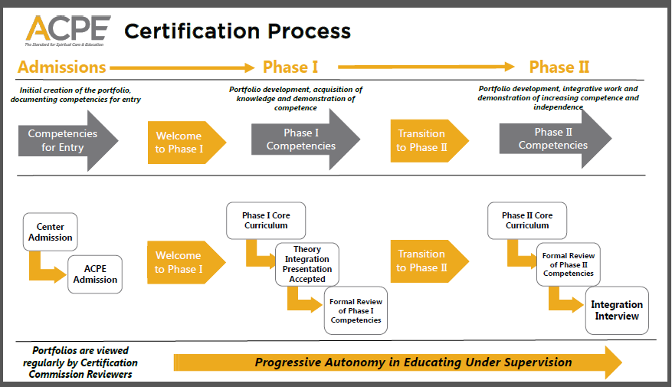

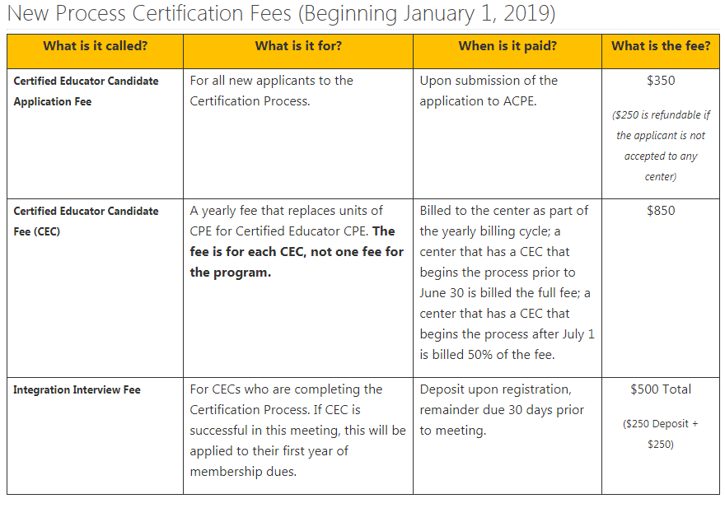
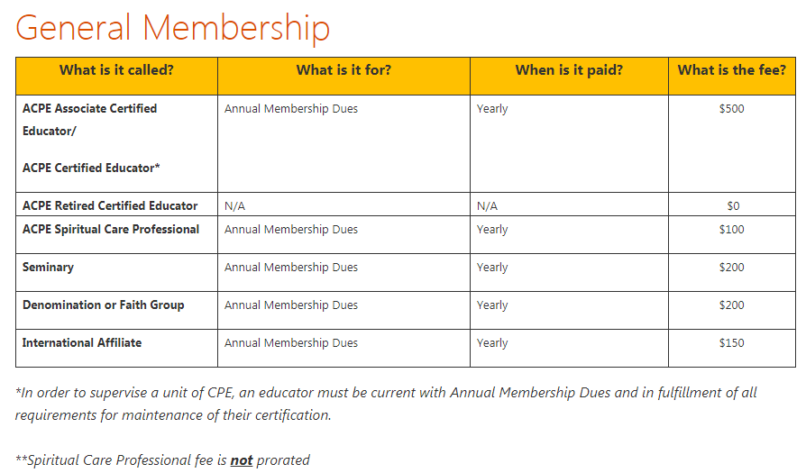

Accredited CPE Centers
https://www.acpe.edu/ACPE/Accreditation/Accredited_Center_Directory/ACPE/Directory/Accredited_Centers.aspx?hkey=69a7a288-ab0e-40c6-b59b-687ace4b8045

