Seventh-day Adventist Theological Seminary
GSEM620
Research Methods
Spring, 2016

Ricardo Norton—DMin, PhD

GSEM620
Research Methods
Spring 2016

General Class information

Class location: North Pacific Union
Class time/day: Sunday 6-9:00 pm. Monday-Thursday 8am to 6pm—1 Hour noon break
Credits offered: 03 credits

Instructor Contact

Instructor: Ricardo Norton—DMin, PhD
Telephone: 269-471-8318
Email: ricardo@andrews.edu
Office location: S 233

course description

An introduction to research techniques and tools. A research paper is required.

course materials

Required:

- Creswell, J. W. (2002). Educational research: Planning, conducting, and evaluating quantitative and qualitative research. Upper Saddle River, NJ: Pearson Education.
- O’Leary Zina. (2005). Researching real-world problems: A guide to methods of inquiry. Sage Publications. Great Britain: TJ International, Padstow, Cornwall.

Recommended:

- Patten, Mildred L. (2009). Understanding Research Methods: An Overview of the Essentials (7th Edition). Glendale, CA: Pyrczak Publishing.
- Pyrczak, Fred & Bruce, Randall R. (2007). Writing Empirical Research Reports: A Basic Guide for Students of the Social and Behavioral Sciences (6th edition). Glendale, CA: Pyrczak Publishing.

revision statement
The instructor reserves the right to revise the syllabus for the benefit of the learning process with appropriate notification to the students.

oUTCOMES

Program Learning Outcomes (PO)

MA in Pastoral Ministry (MAPM) English & Spanish Program Outcomes
- Delivers effective biblically based sermons.
- Demonstrates proper biblical interpretation skills.
- Understands the historical–theological and missional development of the Adventist Church.
- Trains church members for evangelism.
- Empowers church members for leadership.
- Capable of reaching specific social groups.

Student Learning Outcomes (SLO) The student should be able to:

- Access valuable sources from the Internet and the James White Library (JeWel).
- Identify and use different research methods.
- Use research tools for gathering information.
- Implement and evaluate interventive research projects.
- Write research reports according to Andrews University Standard for Written Work, using appropriate organizational levels, and following semantic and syntax rules.

Topics and Assignments

Month | Date | Class Topic | Assignments Due
Sept 2015  to  Jan 2016 |  | Complete 30 hours of reading from the Required and Recommended list of book, above | January 31, 2016  - First day of class  - Late reports—6 point deduction
January  2016 | 31 | - Review course requirements  - Introduction to research  - Using Internet resources  - (SLO 1) | Devotional. Daily small group discussion and collaborative learning sessions on the subject
February  2016 | 1 | Research methods  - Inductive research and the scientific method  - Action research  - Qualitative and quantitative  - Mix methods  - Program evaluation  - (SLO 2). | Devotional. Daily small group discussion and collaborative learning sessions on the subject
 | 2 | Research tools for gathering information  - Guidelines for collecting data  - Instruments for data collection  - Reliability and validity  - Sampling  - Data analysis  - (SLO 3) | Devotional. Daily small group discussion and collaborative learning sessions on the subject
 | 3 | Research reports  - Managing subjectivities  - Report Stories  - Communicating Results  - Types of Reports—Dissertations, thesis, papers  - Report Sections  - Dissertation Structure by Chapters  - The Marks of a Good Report  - (SLO 4) | Devotional. Daily small group discussion and collaborative learning sessions on the subject
 | 4 | Written papers and research reports  - Educational Level of Writers—test  - Scholarly writing  - Causes for Poor Writing  - Insights on Writing  - (SLO 5) | Devotional. Daily small group discussion and collaborative learning. Small group presentations based on collaborative learning during the week. Presentations are graded by peers from a 1-10 point scale. (10 points of the final grade).
May | 1 |  | Final project is due today (May 1). Email an electronic MSW 20-page final research paper before midnight to: ricardo@andrews.edu
June | 1 |  | Late assignments receive no more than a B by midnight on this day (June 1).
July | 1 |  | Late assignments receive no more than a C by midnight this day (July 1).
July | 22 |  | 172 days from the first day of class. Students who have not completed all intensive requirements by July 22, 2016 will receive a DN and will need to repeat the class.

Grading and Assessment

Credit-Hour Definitions
A professional 3-credit course taken at the Seventh-day Adventist Theological Seminary requires a total of 135 hours for course lectures, reading requirements and written assignments:
- Class Lectures and guided studies: 45 hours
- Pre Intensive Reading Report: 30 hours
- Post-Intensive Project Report: 60 hours
- Total: 135 hours

Criteria for Grades
- Pre-Intensive Reading Report 30 Points
- During the intensive group presentation 10 points
- Post Intensive Project Report (20 pages) 60 Points
- Total: 100 Points

Reading Report Criteria
- A total of 30 hours from the required and recommended list—1 point per hour read—up to 30 hours. This report is due the first day of class (January 31, 2016). There is a 6-point deduction for late submission of this report.

Collaborative Learning Presentation
- Course participants will be organized in small groups during the first day of class to discuss and research on a ministerial challenge or issue. Time will be allowed during the week for this task.
- The findings will be presented to peers using Power Point technology during the last day of class (Feb 4).
- The presentation should take no more than 30 minutes and the Power Point slides should be shared with all classmates.
- Each participant will grade group members with a 1-10 scale taking into account a) Contents, b) organization of the material, and c) delivery. The points will count towards the final grade of the course.

Research Project Report Criteria
- Students will have 3 months after the beginning of the intensive to complete a 20-page research project based on topics unveiled during the intensive.
- The report will have the following sections: 1) Title page. 2) Table of Contents. 3) Introduction. 4) Theoretical foundations about the topic—content should be biblical and should integrate current literature on the subjects, a minimum of 15 sources from the past 10 years. 5) Description of the project—including implementation plans or implementation narrative—if the project is implemented. 6) Conclusion. 7) Reference list.
- A detailed outline of the final research project should be prepared by students, during the intensive, and presented to the professor for approval.
- The project will be graded following the criteria of the “Rubric for Assessing Research Projects”—Below. The report should follow Andrews University Standards for Written Work.
- This report is due on May 1, 2016.

Passing Grades
Passing grades should be C or above, based on the following percentages:
A = 95- 100% | B- = 80-82% | D+ = 67-69%
A- = 90 - 94% | C+ = 77-79% | D = 60-66%
B+ = 87- 89% | C = 73-76% | F = Less than 60%
B = 83- 86% | C- = 70-72%

Assignment Submission
Assignments should be submitted in MSW files to the professor’s email (ricardo@andrews.edu).

Late Submission Penalties
- Pre intensive—Due first day of class (6 points deduction)
- Post-Intensive project (See explanation of deductions under “Due Date” in the “Topics and Assignments” Table).

Rubric for Assessing Research Projects
Student
Criteria | (5)  Exceptional | (4)  Proficient | (3)  Satisfactory | (2)  Emerging | (1)  Unsatisfactory | Score
Title Page | Includes: 1) institution’s name, 2) title, 3) name of the course, 4) course period, 5) name of the student, 6) date submitted, 7) follows AU Standards for Written work (AUSWW). Shows o errors | Misses 1 of the 7 components | Misses 2 of the 7 components | Misses 3 components | Misses more than 3 components
Introduc-tion | The introduction is engaging, states the main topic and purpose of the paper, and previews the structure of the paper | Introduction states the main topic and purpose of the paper and previews its structure | States the main topic and purpose of the paper but does not adequately previews its structure | The introduction states the main topic but lack a purpose and a preview of its structure | There is no clear introduction or main topic and the structure of the paper is missing
Content | Content is focused, ideas are well developed and transitions are used to enhance ideas. Each paragraph has thoughtful supporting sentences. Meets paper length requirements. Uses recently published sources and exceeds the use of sources and number of pages recommended | Content is focused. Good transitions. Paragraph development is present. Meets paper length requirements. Uses a minimum of 15 sources published in the past 10 years | Content is focused. Transitions are deficient. Paragraph development is present but not perfected. Meets paper length requirements | Content is not well focused. Transitions and paragraphs are weak. Does not meets paper length requirements | The paper is written and completely out of focus
Project  Description | Project is described in detail. Protocols to be followed are presented. Specific aspects of the organization, implementation, and evaluation are offered. Meets paper length requirements | Project is well described. Some details regarding protocols, organization, implementation, and evaluation of the project are missing. Meets length | Project is satisfactorily described and meets paper length | Project is poorly describes and does not meet number of pages. | The report misses entire sections of the project description. Does not meet paper length.
Organization | Report provides a table of contents, and is organized using different subhead levels, following AUSWW. Subheadings are exceptionally well-worded and reflect upon the main subject. Exceeds all organizational specifications stated in the syllabus | Table of contents and subheading levels follow AUSWW Standards. Subtitles reflects upon the subject but wording need can be improved. | Paper provides a table of contents and is organized using different subheading level. However, do not follow AU standards of written work | Paper provides first level headings but headings do not clearly reflect upon the subject. No table of contents. Does not follow all specifications stated in the syllabus and AUSWW | Does not provide a table of contents and is not divided under headings and subheadings. Does not follow organizational specifications stated in the syllabus and AUSWW
Format/Style | All text and reference following specification from AUSWW. Syntax and semantics are outstanding. Models language and style. No errors in errors in punctuation, spelling, and sentence formation | Follows consistently AUSWW with minor flaws. Syntax and semantics is very good. No major errors in style | Follows consistently all format AUSWW. Syntax and semantics are good. Few errors in style | Follows inconsistently some AUSWW. Syntax and semantics is poor | Does not follow AUSWW. Syntax and semantics are deficient
Conclusion | Conclusion is engaging and provides an outstanding overview of the project and personal reflections on projected implementation. Exceeds expectations | Conclusion restates the purpose, gives a good summary, and provides personal opinions about the outcome | Conclusion restates the purpose and satisfactorily summarizes results Lacks personal reflection on projected implementation | Conclusion attempts to summarize the trust of the project but is ambiguous. Lacks personal reflection | Conclusion fails to summarize and to express personal reflection on the project

Class policies

Classroom Seating
In order to facilitate learning everyone’s name please select a permanent seat until instructed otherwise.

Disability Accommodations
If you qualify for accommodation under the American Disabilities Act, please contact Student Success in Nethery Hall 100 (disabilities@andrews.edu or 269-471-6096) as soon as possible so that accommodations can be arranged.

Class Attendance
“Regular attendance at all classes, laboratories and other academic appointments is required for each student. Faculty members are expected to keep regular attendance records. The syllabus notifies students of the attendance requirements. AU Bulletin

Teacher Tardiness
“Teachers have the responsibility of getting to class on time. If a teacher is detained and will be late, the teacher must send a message to the class with directions. If after 10 minutes no message has been received, students may leave without penalty. If teacher tardiness persists, students have the right to notify the department chair, or if the teacher is the department chair, to notify the dean”. AU Bulletin

Class Absences
“Whenever the number of absences exceeds 20% (10% for graduate classes) of the total course appointments, the teacher may give a failing grade. Merely being absent from campus does not exempt the student from this policy. Absences recorded because of late registration, suspension, and early/late vacation leaves are not excused. The class work missed may be made up only if the teacher allows. Three tardies are equal to one absence.

Registered students are considered class members until they file a Change of Registration form in the Office of Academic records”. AU Bulletin

Excused Absences
“Excuses for absences due to illness are granted by the teacher. Proof of illness is required. Residence hall students are required to see a nurse on the first day of any illness which interferes with class attendance. Non-residence hall students should show written verification of illness obtained from their own physician. Excuses for absences not due to illness are issued directly to the dean’s office. Excused absences do not remove the student’s responsibility to complete all requirements of a course. Class work is made up by permission of the teacher”. AU Bulletin

Academic Integrity
“In harmony with the mission statement (p.18), Andrews University expects that students will demonstrate the ability to think clearly for themselves and exhibit personal and moral integrity in every sphere of life. Thus, students are expected to display honesty in all academic matters.

Academic dishonesty includes (but is not limited to) the following acts: falsifying official documents; plagiarizing, which includes copying others’ published work, and/or failing to give credit properly to other authors and creators; misusing copyrighted material and/or violating licensing agreements (actions that may result in legal action in addition to disciplinary action taken by the University); using media from any source or medium, including the Internet (e.g., print, visual images, music) with the intent to mislead, deceive or defraud; presenting another’s work as one’s own (e.g. placement exams, homework, assignments); using material during a quiz or examination other than those specifically allowed by the teacher or program; stealing, accepting, or studying from stolen quizzes or examination materials; copying from another student during a regular or take-home test or quiz; assisting another in acts of academic dishonesty (e.g., falsifying attendance records, providing unauthorized course materials).

Andrews University takes seriously all acts of academic dishonesty. Such acts as described above are subject to incremental discipline for multiple offenses and severe penalties for some offenses. These acts are tracked in the office of the Provost. Repeated and/or flagrant offenses will be referred to the Committee for Academic Integrity for recommendations on further penalties. Consequences may include denial of admission, revocation of admission, warning from a teacher with or without formal documentation, warning from a chair or academic dean with formal documentation, receipt of a reduced or failing grade with or without notation of the reason on the transcript, suspension or dismissal from the course, suspension or dismissal from the program, expulsion from the university, or degree cancellation. Disciplinary action may be retroactive if academic dishonesty becomes apparent after the student leaves the course, program or university

Departments or faculty members may publish additional, perhaps more stringent, penalties for academic dishonesty in specific programs or courses”. AU Bulletin

Language and Grammar
There is an expectation that a student enrolled in a graduate program possesses advanced written language skills, particularly in the language in which the degree is acquired. Thus, no special consideration will be given to English as a second language learners or native-English speakers who have yet to obtain mastery in written English. Such students are advised to seek the assistance of the campus writing lab or procure the services of an editor prior to the submission of their assignments. Tips for success include reading your assignments aloud and having someone else do likewise prior to submission. This practice will provide you with immediate feedback on your written assignments.
Emergency Protocol
Andrews University takes the safety of its student seriously. Signs identifying emergency protocol are posted throughout buildings. Instructors will provide guidance and direction to students in the classroom in the event of an emergency affecting that specific location. It is important that you follow these instructions and stay with your instructor during any evacuation or sheltering emergency.

Instructor Profile

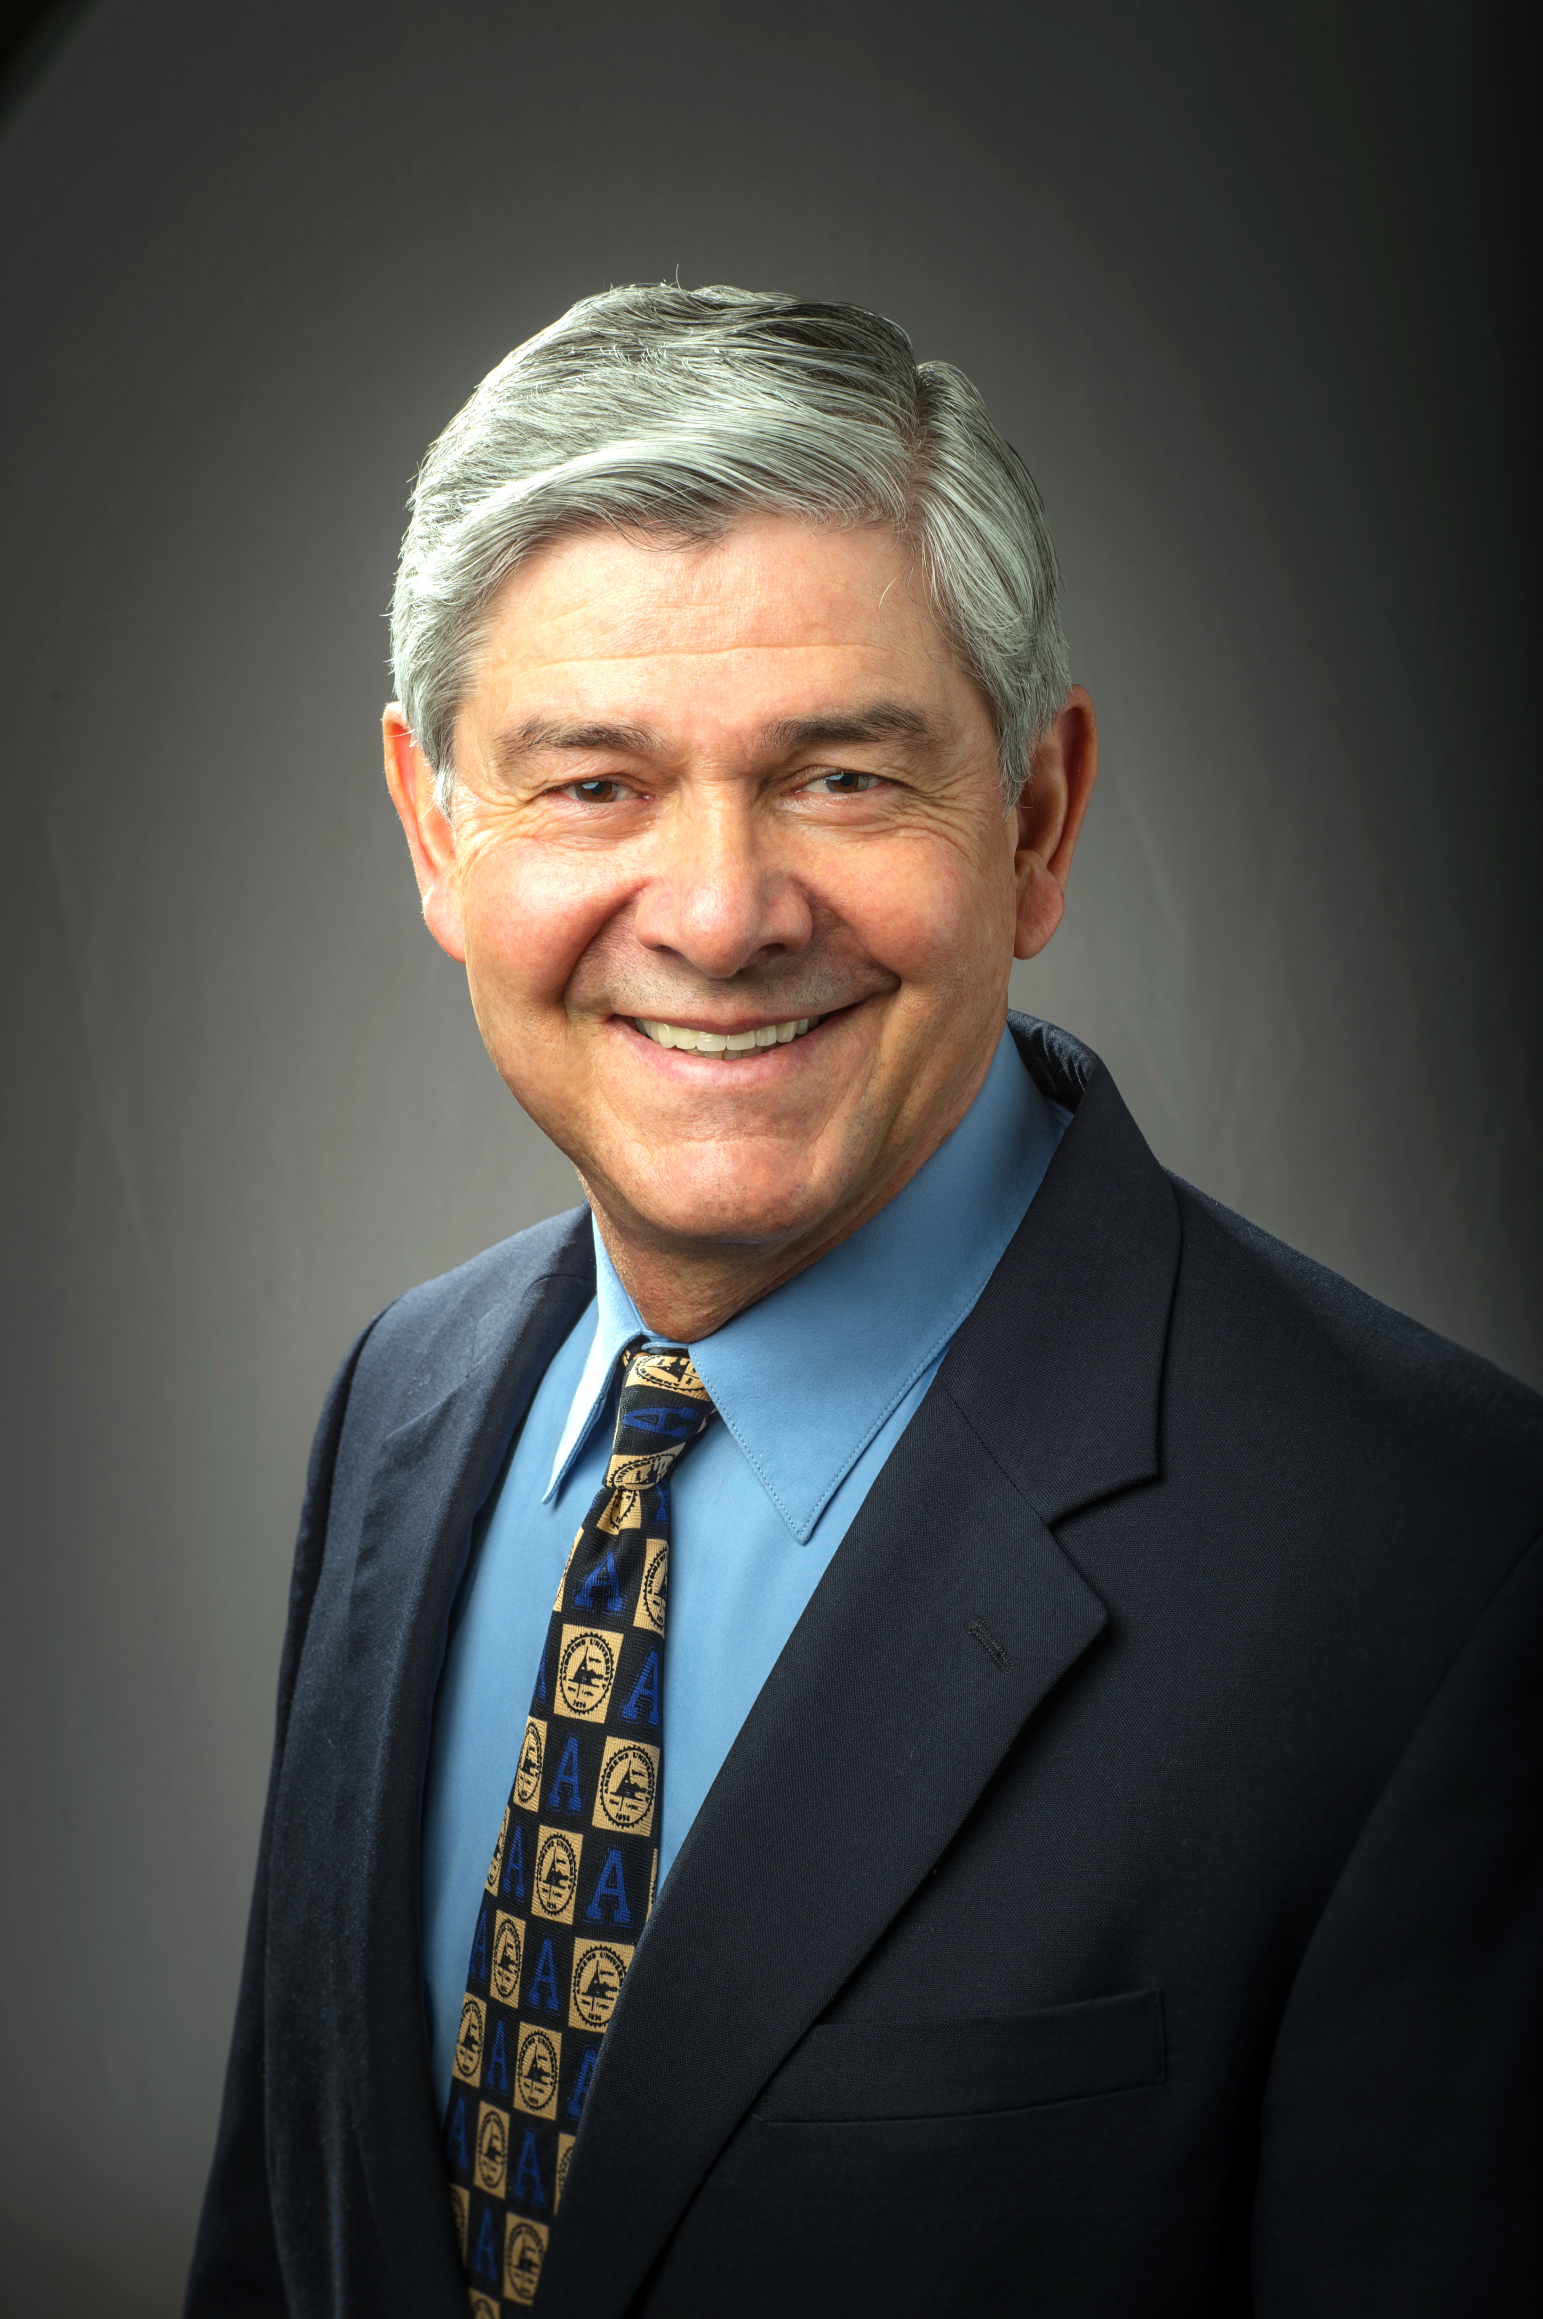

Ricardo Norton (DMin, PhD) has taught at the Seventh-day Theological Seminary since 1996. He currently directs a Masters Program and coordinates three DMin cohorts. In addition, he is the founder of a lay training program (Seminario Adventista Laico—SAL) with over 5,000 students spread in 14 different countries. His lectures and writings carry the weight of serious investigation and the practical knowledge that 40 years of teaching and ministerial experience confer. He travels extensively in the U.S. and abroad, teaching pastors and lay leaders how to make their churches grow.

