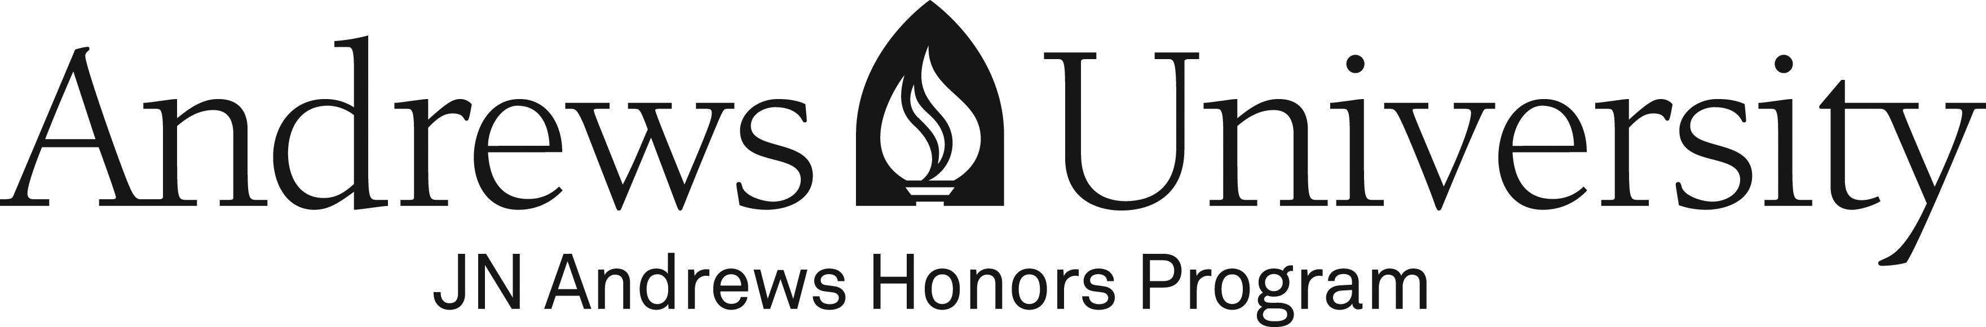

Honor Code

I, ________________________________________, agree to behave with the utmost integrity (print name)
as a participant in the learning community of Andrews University and the J. N. Andrews
Honors Program.

I understand that academic gifts and enhanced learning opportunities come with privileges and responsibilities. I will use my knowledge and understanding gained in this program in a spirit of generous service and humility.

I understand that academic dishonesty includes (but is not limited to) the following acts:

- Falsifying official documents;

- Plagiarizing, which includes copying others’ published work, and/or failing to give credit properly to other authors and creators;

- Misusing copyrighted material and/or violating licensing agreements (actions that may result in legal action in addition to disciplinary action taken by the University);

- Using media from any source or medium, including the Internet (e.g., print, visual images, music) with the intent to mislead, deceive or defraud;

- Presenting another’s work as one’s own (e.g., placement exams, homework assignments);

- Using materials during a quiz or examination other than those specifically allowed by the teacher or program;

- Stealing, accepting, or studying from stolen quizzes or examination materials;

- Copying from another student during a regular or take-home test or quiz;

- Assisting another in acts of academic dishonesty (e.g., falsifying attendance records, providing unauthorized course materials).

I understand that the punishment for academic dishonesty is at the discretion of the Honors Program professor in accordance with Andrews University policy.

I understand that repeated offenses will result in notification of the Director of Honors and expulsion from the J. N. Andrews Honors Program.

__________________________________________ _________________
Signature Date

