**General Physics eJournal 8**

**Static Equilibrium**

**Instructions:**

Follow the Writeup and fill out the eJournal as you complete the lab activities. Submit your eJournal report by uploading the completed WORD or PDF document to our class Learninghub site. If the Learninghub site is down, email the completed report file directly to a lab TA.

**Preliminaries:**

* Title:
* Name(s):
* Date:
* Time In & Out:

**Plan:**

**Hypothesis**

Sketch a free-body diagram of a horizontal beam (of weight, mRg) supported at the near end by a normal support, carrying two additional weights and suspended at the far end by a vertical rope (there should be 5 forces). Identify and label each of the forces, distances, and angles. Formulate a hypothesis regarding the net torque about the near, supported end.

*Insert image of your free-body diagram*

**Experiment Outline**

Briefly describe your plan for testing your hypotheses.

**Equipment List**

* List
* Equipment
* Here

**Action:**

Describe the techniques used to collect data by responding to the bullet point questions:

* How did you weigh the ruler?
* How did you measure the ruler’s length and center of gravity?
* Where did you attach the pennies?
* How did you determine/set the angle of the spring balance force?

*Insert labeled image of your apparatus*

**Results:**

Record the length of the ruler (beam) in meters.

Length of Ruler: L = ____________ m

Record the mass of the ruler, mR, and the two loads, m1 and m2, in kg. Record the lever arm distances for the ruler, xcg, and the two loads, x1 and x2, in meters. Calculate and record the weights of the ruler and the two loads (W = mg). Record the force, Fs, measured by the spring balance. The lever arm distance for the spring balance is the length of the ruler, L.

**Table I: Mass, Force, Distance, Angle, and Torque   
with Perpendicular Forces acting on a Horizontal Beam**

|  |  |  |  |  |  |
| --- | --- | --- | --- | --- | --- |
|  | **Mass (kg)** | **Weight/ Force (N)** | **Distance, x (m)** | **Angle (deg)** | **Torque, τ (N∙m)** |
| **Beam** |  |  |  | 90 |  |
| **Load 1** |  |  |  | 90 |  |
| **Load 2** |  |  |  | 90 |  |
| **Spring Balance** | ------- |  |  | 90 |  |

**Table II: Mass, Force, Distance, Angle, and Torque   
with Non-Perpendicular Forces acting on a Horizontal Beam**

|  |  |  |  |  |  |
| --- | --- | --- | --- | --- | --- |
|  | **Mass (kg)** | **Weight/ Force (N)** | **Distance, x (m)** | **Angle (deg)** | **Torque, τ (N∙m)** |
| **Beam** |  |  |  | 90 |  |
| **Load 1** |  |  |  | 90 |  |
| **Load 2** |  |  |  | 90 |  |
| **Spring Balance** | ------- |  |  |  |  |

**Analysis:**

For both cases (perpendicular forces and non-perpendicular forces), calculate the torque exerted by each item (counterclockwise +, clockwise -) and record in Tables I & II.

Sum all the CCW torques and all the CW torques. Demonstrate that the sum of the torques about the point x = 0 is zero by computing the percent difference between the CCW and CW torques (Eq. 4). Record these results in Tables III & IV.

**Table III: Clockwise vs. Counterclockwise Torques   
with Perpendicular Forces acting on a Horizontal Beam**

|  |  |  |  |
| --- | --- | --- | --- |
| $τ_{CCW}$**(N∙m)** | $τ_{CW}$**(N∙m)** | $τ_{net}=τ_{CCW}+τ_{CW}$**(N∙m)** | **%Diff** |
|  |  |  |  |

**Table IV: Clockwise vs. Counterclockwise Torques   
with Non-Perpendicular Forces acting on a Horizontal Beam**

|  |  |  |  |
| --- | --- | --- | --- |
| $τ_{CCW}$**(N∙m)** | $τ_{CW}$**(N∙m)** | $τ_{net}=τ_{CCW}+τ_{CW}$**(N∙m)** | **%Diff** |
|  |  |  |  |

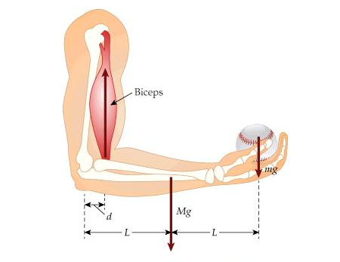**Conclusion:**

Interpret your results in light of your hypothetical predictions. How close were the CW and CCW torques? How did the torque from the spring balance compare between the two cases (perpendicular vs. non-perpendicular)? How might you improve this experiment or explore it further? How could you modify the experiment to model a horizontal forearm holding a load as shown?