Steps for data processing. (10/24/2007)

1) Unpack this analysis toolkit into the appropriate directory.
You will need to open a command prompt window. Do this by pressing +R or selecting “Run…” from the Start Menu.

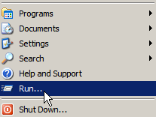

In the Run dialog, enter cmd.exe and click on OK.

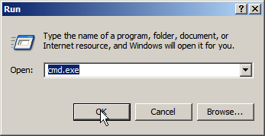

This will open a command prompt window. Change to the correct directory by typing cd “c:\path\to\directory\”, where the path in quotations is the path to the directory where you unpacked the analysis toolkit.

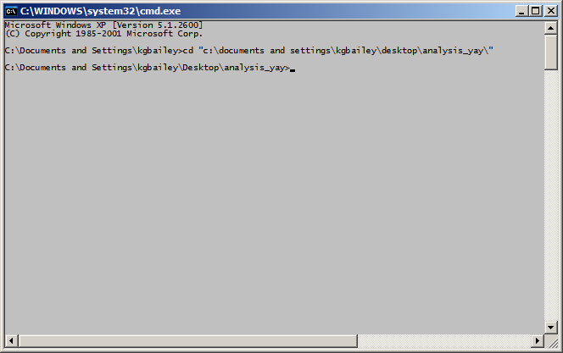
The unpacked toolkit will look something like this:

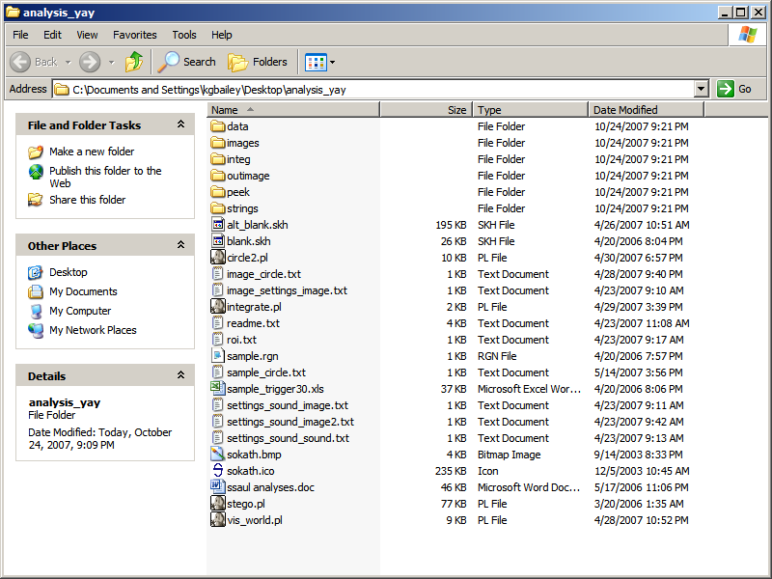

You may not need all of the folders for your analysis, but they are there!

2) Next, place all raw data files (copied from the eye tracking computers) into the \data directory. Use isit30.pl and 30_60.pl to make certain that all data files are at the same frame rate. Type:

cd data (to move to the \data directory from the root directory)
isit30.pl (to run the program)

The output of isit30.pl consist of two lines per file: the first is the filename, and the second is the number of frames per second. If any of your files are 30FPS, you will need to reduce all of your files to 30FPS in order to analyze the data.

Convert the files by first renaming all of the files so that they have either a _30.txt or a _60.txt suffix (depending on the frame rate of each file – so 11235813.txt would become 11235813_60.txt if it was at 60FPS). This can be done by highlighting each file in the data directory in turn and pressing F2 in order to activate renaming.

Once all of the files are renamed, run 30_60.pl to convert the 60FPS files to 30FPS files. If you don’t need 30FPS files, skip this step.

30_60.pl

The new 30FPS files will automatically be placed in the data directory.

3) Set up the control files for the program (vis_world.pl) that converts raw data into fixations and saccades as follows:

Create a _setup.txt file in the root directory using the _setup.txt templates (image_settings_image.txt, settings_sound_image.txt, settings_sound_image2.txt, settings_sound_sound.txt). The first part of the template name is the trial identifier (including information about conditions contained in the identifier filename), the second part of the filename is the trigger to start recording eye tracking data, and the third part is the trigger to stop recording eye tracking data.

The vis_world.pl program reads through each listed raw data file and looks for critical trials (according to the regular expression you provide – leaving out fillers, etc.). The first line of this file should list each relevant raw data file (from the data directory) in tab-delimited format. The second line is used to identify the type of trial identifier indicating relevant trials within the raw data files. The third and fourth lines identify the types of markers for starting and stopping fixation/saccade recording. The fifth through seventh lines are the regular expressions that specifically select the relevant trials and start/stop points. The first through fourth parentheses in the trial ID regex (fifth line) correspond to the trial number and three conditions, respectively. The eighth line indicates which button presses to record and output in answer_log.txt. Read the _setup.txt files for more information.

Rename your completed _setup.txt file so that it ends with, obviously, _setup.txt.

Create a tab-delimited ROI (regions of interest) file with the regex of the number to search for in the first column and the code associated with that number in the second column. Read the roi.txt sample file for more details. Note that two digits numbers need to come before one digit numbers.

4) Run vis_world.pl to translate the raw data files (in the data directory) into fixation/saccade files (in the peek directory). Be sure that you have a _setup.txt file and an roi.txt file. Type:

cd .. (to return to the root directory from the \data directory)
vis_world.pl (to run the program)

The program will prompt you for some information. At the first prompt, enter the filename of the _setup.txt control file (without the file path). At the second prompt, enter the filename of the ROI control file. The output of the program (on-screen) is the contents of the control files (to double check your input) and an ongoing list of files processed. Completed files are automatically saved to the peek directory.

When vis_world.pl completes, open the \peek directory. Check to make sure that there are full trials, and that they are about the length (remember to multiply by FPS to get number of seconds) that you expect.

5) Set up files for Sokath analysis.

Open the blank.skh file in Microsoft Excel and all fixation/saccade files from the peek directory. Copy each fixation/saccade file into a separate worksheet in the .skh file (starting with sheet ‘subject 1’, and delete all empty worksheets. Save the .skh file under a new name.

Set up a .rgn file (this can be done in Notepad) that will identify conditions and ROIs to Sokath. A sample.rgn file is included. This must match the output from (3) and (4) in terms of the condition names (look at a peek file) above for Sokath to properly process your data.

Create a trigger file with analysis time segments. This is an Excel file - a 30 Hz sample is included. For 60 Hz analysis, simply double the amount of time (e.g. 2 seconds >>> 4 seconds).

6) Convert the fixation/saccade files into strings for statistical analysis and preview your data.

Run Sokath. Type:

stego.pl -f regionfile (leave off the .rgn extension of the region file)

This will open a Sokath window. Turn off raw data updating by pressing CTRL-G.

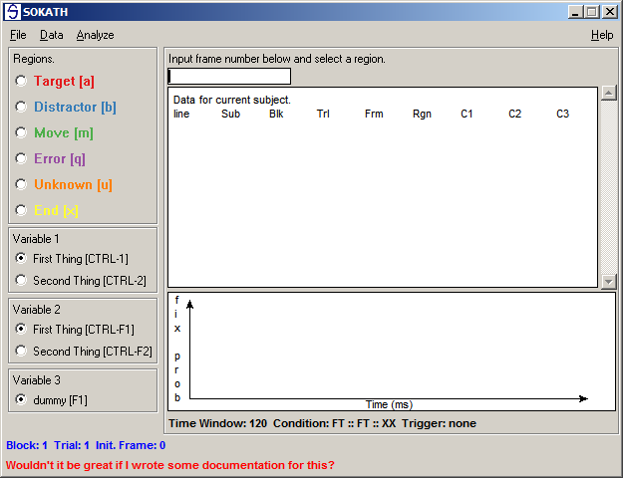

Open the .skh data file that you set up in (5) by pressing CTRL-O and selecting the file.

Open the appropriate trigger file by selecting Load Trigger File from the Analyze menu.

Press CTRL-R and select a trigger for analysis.

Select an appropriate time window (in number of frames – remember to take into account FPS when converting from seconds into frames) for analysis using the Set Time Window option under the Analyze menu.

Select the condition for analysis (CTRL-A).

Preview your data using the Momentary Fixation Probability graph option by pressing CTRL-F. If the graph shows no data, there may be mismatch between the region file and the peek data in the .skh file.

Preview other graphs as necessary. When finished, output all of the strings to disk by pressing CTRL-M, navigating to the /strings directory, and saving as any filename (the filename is discarded by the program). When complete, close Sokath.

7) Use ssaul.pl to produce summary tables by participant or item for analysis in SPSS or Excel.

The program will first ask for the string file that you want to analyze with the prompt Input file?.

Next, the program will request the region of interest (ROI) that you want to produce a summary table for with the prompt Region code(s)?. If you want more than one ROI to be counted in your analysis, separate the codes with a pipe [|].

The program will then ask for a output filename (Output file?). If you enter an existing filename, your summary table will be appended to existing tables.

You can choose to treat either subjects or items as random samples at the [1] subject or [2] item analysis? prompt by entering either 1 or 2.

Lastly, choose the appropriate analysis (see table and list below for current analyses). You may be prompted for the marker for movements (it’s almost always MV). The ssaul.pl program will output your table and open the file up in Notepad (scroll to the end of the file to see the table if there are multiple tables). The program will also output a command line string that you can use to re-run the same analysis later. You can save this in a file ending in .bat if you want to run a number of analyses in a row (append a -p n if you want to suppress the file from opening in Notepad).

You should probably check the graphs for each individual participant at some point using analysis 7 (which will prompt for a subject number – the number corresponds to the number of the sheet in the .skh file). Look for over-representation of unknown (UNK) and saccade (MV) columns – this usually indicates severe track loss.

If you are concerned about the following time frame …► | entire trial | initial epoch
…and you want the following type of data …▼ | entire trial | initial epoch
average number of fixations per trial on ROI | 2 | 11, 12
proportion of trials with saccade to a given ROI |  | 20, 23
proportion of trials with fixation on a given ROI | 1, 6, 7 | 10, 15, 16
average time spent fixating ROI per trial | 4
percent time spent fixating ROI per trial | 5 | 14
total frequency of fixation on ROI per subject |  | 13
total frequency of saccade to ROI per subject |  | 21, 22
time to first fixation on ROI | 3

Analyses available:
[1] Proportion of trials with fixation on a given ROI (entire trial)
[2] Average number of fixations per trial on a given ROI (entire trial)
[3] Time to first fixation on a given ROI (entire trial)
[4] Average number of frames spent fixating on a given ROI (entire trial)
[5] Proportion of time spent fixating on a given ROI (entire trial)
[6] Momentary fixation probability graphs (entire trial)
[7] Momentary fixation probability graphs (entire trial; one subject)
[10] Proportion of trials with fixation on a given ROI (initial epoch)
[11] Average number of fixations per trial on a given ROI (initial epoch)
[12] Average number of fixations per trial on a given ROI (initial epoch; alt)
[13] Total frequency of fixation on a given ROI (initial epoch)
[14] Proportion of time spent fixating on a given ROI (initial epoch)
[15] Initial probability of fixation on a given ROI (initial epoch).
[16] Proportion of trials with fixation on a given ROI - MFA format (initial epoch).
[20] Proportion of trials with saccade to a given ROI (initial epoch)
[21] Total frequency of saccade to a given ROI (initial epoch)
[22] Total frequency of saccade per trial to a given ROI (initial epoch).
[23] Proportion of trials with saccade to a given ROI - MFA format (initial epoch).
[30] simple string summary
[31] Simplify strings
[32] Fixation pattern frequencies
[33] Single string comp (precedence matching)
[34] Single string comp (edit distance)
[35] Pre cluster (precedence matching)
[36] Pre cluster (edit distance)
[37] Markov analysis

