The
Principal as Board Officer

e expect a lot from Adventist principals. We want die principal to be a spiritual leader, a manager of the school's resources, an instructional leader who supervises teachers and staff, a fund raiser, a curriculum specialist, a friend of students, a disciplinarian of students, a master communicator, a stimulator of student academic and spiritual growth, a coordinator of professional growth for all employees, and a liaison with the home and school organization.
Since up to one-third of a board is new each school year, the principal should annually review with the board the generally accepted governance practices of effective boards.

On top of all this, we ask the principal to be the executive secretary of the school board. Besides keeping an accurate written record of all board meetings, he or she is to implement the actions of the board. But it does not stop there. Since the principal is often die only professional educator on the board (superintendents do not attend ever)' meeting), he or she must educate the board as to their roles and responsibilities.
Functions of the Board
Since up to one-third of a board is new each school year, die principal should annually review widi the board the generally accepted governance practices of effective boards. These functions and roles may be obtained from union conference education codes or professional organizations such as the National School Boards Association.
By Ed Boyatt
As pointed out in an earlier boardsmanship article in this journal,¹ effective boards fulfill four essential roles—and the principal has a key involvement in each.
1. First, the principal and the board must establish a vision for the school. Some members believe that Adventist schools are overmanaged and under-led. This means that many principals do not take a strong role in leading their teachers and helping their board define desired goals for the future of their school. Since excellence includes "continual improvement," quality boards should set improvement goals each year. As Lyndon Furst writes elsewhere in this issue, the principal has both a

10 Journal of Adventist Education SUMMER 2004




management and leadership role to balance. Visioning, strategic planning, and goal setting are all part of the principal's responsibility.

- Next, the school board votes policies and finds resources to support the vision and mission of the school. This is the area where boards spend most: of their time. This function involves reviewing the financial status of the school each month and establishing policies that supplement die working policies of the division and of the union conference education code. Since board members do not usually have a copy of these two policy books, members expect the principal and superintendent to be knowledgeable about and to explain die applicable policies (conference, union, and division levels) when various issues arise.
- Another major function of the board is to assess progress toward the goals of the school and to ensure account-
The principal and the board must establish a vision for the school
ability to the constituency. As with most functions of the board, members expect the principal and conference office of education to oversee the essential assessments. This includes standardized academic achievement tests, which are administered annually by the conference, and annual evaluations of all employees, which are conducted by the principal and superintendent.
A bigger challenge to principals and boards is to assess the spiritual growdi and development of students. The short form of the Valuegenesis survey is an excellent assessment tool
that provides a longitudinal spiritual profile if conducted annually.²
4. Finally, board members are advocates for students and Adventist education. Principals model diis commitment to their board by visiting churches and church boards during the school year, giving reports that demonstrate the success of their school. The more oiten principals share widi the constituency die good news of Adventist education, the more likely that parents will see the value of Christian education for their children.
These four functions are fundamental to effective Adventist school boards. They are the what, the bow, the how well, and the marketing of Adventist education. Establishing a vision of a preferred future is the what, maintaining an organizational structure to support the vision is the bow, assessing the progress of the school

Journal of Adventist Education SUMMER 2004 11

and ensuring accountability is the how
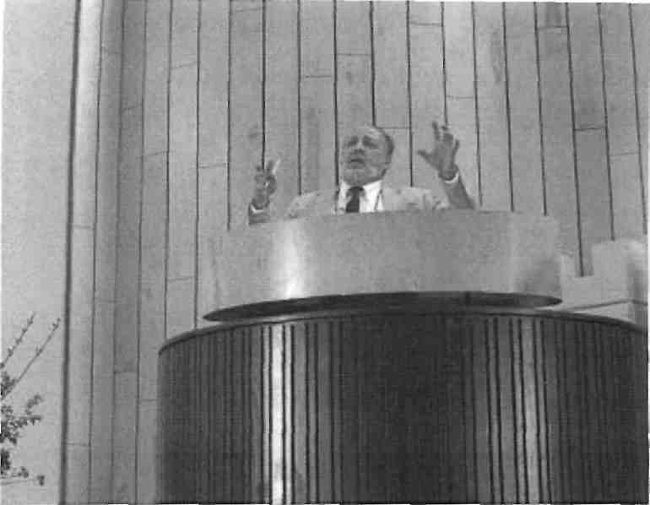
The more often principals share with the constituency the good news of Adventist education, the more likely that parents will see the value of Christian education for their children.
well, and the communication of the importance of our youth and of Ad-ventist education is the 'marketing role of each board member.⁵ The Advent-ist principal must demonstrate leadership in all these essential functions. That is why the board's most important decision is to recommend to the conference board of education the hiring of a principal who will effectively fill these important roles.
Agenda Development
Effective principals and professional board chairs understand the importance of board agendas and how to develop them. If the school constitution does not contain a process for developing a board agenda, the board should vote a policy describing how to place an item on the agenda. The principal usually is designated to develop the agenda in consultation with the board chair. Thev should discuss the agenda before each board meeting so that they understand the context and directions of potential actions.
Before each board meeting, members should receive by mail the agenda, minutes ot the previous meeting, and supporting documents that need to be reviewed before important items are discussed and voted. This mailing also alerts board members to official actions that will be considered. Board members will learn through this process that new items are usually not placed on the agenda the day of the meeting. It is not fair or wise for the board to take action on an item that the school administrator has not had sufficient time to study and make a recommendation about to the board. If a board member voices a concern not included on the agenda, a wise board chairperson will thank the person for bringing the item to the board's attention and place it on the next meeting's agenda for full discussion and possible action. iMembers must learn to respect the need tor a principal to investigate a concern or research a topic before ac-
Board members are advocates for students and Adventist education.
tion is considered by the board.
Professional Presentations
Since principals usually report to the board on a regular basis, their presentations should model the appropriate components of a professional report. The principals report to the board should include a written outline. Board members can use this outline to report the school's activities and business to their local church board.
When I was a conference education superintendent, I often saw principals request the board to approve off-campus field trips or overnight trips without providing written details. As a result of diis "conceptual approval," the board often knew little about the details of the trip. Such requests should be made in writing and include a description of how the trip meets the code book policy guidelines. They should include details
such as who is going, the destination, length of the trip, the cost to each student, die number of adults supervising, and the source of insurance for vehicles and participants.
When school policy needs to be revised, a new or updated policy is generally recommended by die principal or by a subcommittee of the board. Since each word is important, members deserve the courtesy of receiving recommendations in writing.
Official Documents
Many school boards have found that creating a diree-ring notebook for each board member is a professional way of collecting the actions of the board and constituenq'. The school secretary or administrative assistant then keeps the notebook current. Colored dividers assist in organizing the board minutes, financial statements, operating budget, school handbook, school board constitution, subcommittee minutes, and the recommendations of die most recent accreditation visiting committee. A map of the physical plant may also prove useful during board discussions. I also recommend a section that includes all policies die board has approved with the date when each was voted. The

1 2 Journal of Adventist Education SUMMER 2004

school handbook and board constitution contain most of the board and constituency policy actions, but certain actions are not recorded in either of those official school board documents. If your board has not systematically recorded policy actions, it is beneficial for a new school administrator to take the time to read the board's minutes for the past 10 to 20 years to locate those policy decisions. Reading about the school board's challenges for the past decade or two will also help a new administrator understand the environment in which he or she has been asked to lead.
Student and Faculty Reports
Since assessing the students' academic and spiritual development is a major function of the board, the principal should invite members of the school family to share anecdotal evidence that illustrates student and
Additional Resources
Board members should first seek additional information from the principal and superintendent to aid them in becoming more effective. They can help board members obtain a copy of the guidelines that most union offices of education produce for their region. They also have access to a PowerPoint presentation originally produced in the North Pacific Union that is an excellent resource for a board in-service.
The National School Boards Association conducts regional and national conferences on boards-manship and publishes the American School Board Journal. Check it out at http://www.asbj.com.
Many U.S. states have a school board association. They conduct board member institutes and publish a journal or newsletter. The California Web site is a good place to begin: http://www.csba.org.
Another major Junction of the board is to assess progress toward the goals of the school and to ensure accountability to the constituency.
teacher success. As a superintendent, I looked forward to board meetings that featured curriculum and class activities reports by teachers and students. Board members appreciate learning about innovative teaching methods and approaches that meet student needs and motivate them to achieve. Enthusiastic students can also communicate to board members their perspective on a community-service project or learning activities that have sparked their interest. The credibility of the principal's progress reports to the board is enhanced when teachers and students share examples of excellence that they have experienced.
Financial Reporting
Many principals have treasurers or business managers who know more about school finance than the principal does. That is understandable in an age of specialization. But principals can help the school treasurer/business manager to create a report that all board members can understand. The principal and business manager should begin each year by explaining to board members how to read and understand a monthly financial statement. I often observe in board meetings that only business people ask questions during the reporting session.
The business manager or principal should answer questions that most board members may not ask for fear of revealing their lack of knowledge about finance. The following questions are usually not answered in the typical business report:
1. How much money did we ex-
pect to earn last month?
- How much money was collected last month? How much are we behind in collections for the year? How does that compare to a year ago?
- Are all the bills paid? If not, why not?
- How much money do we have in checking and in savings?
School administrators want board members to understand the budget and its implementation during the year. Principals should help the treasurer/business manager ensure that the budget report is accurate and clearly describes the school's fiscal health.
Efficient Use of Time
A challenge for most school boards is to make efficient and effective use of time. Some boards set a closing time for board meetings. (A policy might read as follows: "All board meetings begin at 7:30 p.m. and end no later than 9:00 p.m. A majority vote is required to extend a board meeting.") This sends a strong message that members want the chairperson to guide the deliberations in an efficient manner.
One way to respect board members' valuable time is for the board to have subcommittees. These subcommittees can be either standing committees like finance, personnel, and safety; or ad hoc committees appointed by the chair to study a particular issue and report back to the board. They may be designated by the school's constitution or chosen by the board. Whether a standing or temporary committee, such groups can save the board valuable time and help ensure informed decision-making. Issues such as personnel and finance are too important not to receive hours of deliberation outside the monthly board meetings. The subcommittees should be encouraged to report in a timely and professional manner.
Principal Evaluation
As mentioned earlier in this arti-

Journal of Adventist Education SUMMER 2004 13

cle, the board helps ensure accountability for excellence in student and employee growth. The superintendent and principal are responsible for annual evaluations of school employees. It is very helpful for die superintendent to include input from board members as well as teachers and staff in his or her evaluation of the principal. This should be done in a professional manner, including written comments about strengths and areas needing improvement.
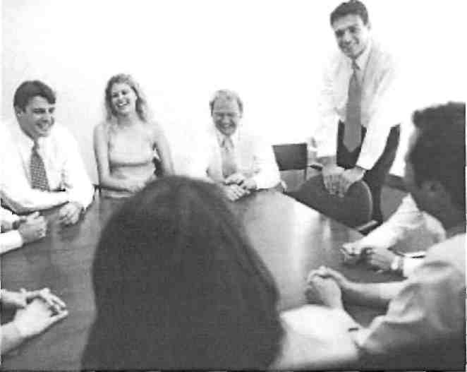
The board walks a fine line in assessing the success of die principal. Even though education codes require the superintendent to conduct the principal's job evaluation, the superintendent should survey die teachers and board to see how they perceive the principal's leadership.
Through visits to the school and discussions with students, teachers, and parents, the board can gain insights about the institution that will be useful in their deliberations. The board's visibility on campus is also a sign of their commitment to the school and its mission.
Board Evaluation
As mentioned earlier, school assessment and accountability are important responsibilities for the principal and board. Principals should discuss staff evaluations with the personnel committee, report students' standardized test scores to the board, and present reports on sendee projects that illustrate the mission of the school. But in their eagerness to assess students and staff, boards often neglect to evaluate themselves. A board self-evaluation can be as simple as asking the following questions:
1. What are our strengths? What is our board doing right?
2. What improvements could we make to be a better board? How can we improve our effectiveness and efficiency?
We expect our schools to improve each year. We set one- and five-year goals. Shouldn't the school board assess itself to better understand how
Effective principals and professional board chairs understand the importance of board agendas and how to develop them.
the members perceive the workings of the board? Healthy boards have a strong desire to serve teachers, students, and constituents more effectively. This implies a need for continual improvement in die deliberations of the board.
Summary
A school board's success depends on the teamwork and collaboration of its members. The principal, as executive secretaiy, fills the most important position on the board in facilitating this success. When the principal demonstrates professionalism, the board will be more efficient and effective. Our community, church, employees, parents, and students deserve
excellence in the governance of our schools. May the Adventist principal be the motivator of excellence that our boards deserve and expect. 0
NOTES AND REFERENCES
- Ed Boyatt, "Boardsmanship 101,"Journal of Adventist Education 62:2 (December 1999/January 2000), pp. 4, 5.
- Learn mure about this survey at the Hancock Center at http://www.lasierra.edu/ centers/hcym.
- Sherry Loofbourrow, Boardsmanship: Maximizing School Board Leadership (West Sacramento, Calif.: California School Board Association, 1996), p. 10.
Dr. Ed Boyatt, Coordinator for this special issue on school hoards, is Associate Professor of Education at La Sierra University in Riverside, California, where he is Chair of the Ad-
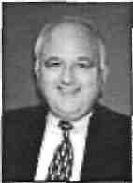
ministration/Leadership Department, lie has served as a secondary teacher, academy principal, college dean of students, union associate director of education, and superintendent of schools for the Oregon Conference. The JOURNAL staff expresses its appreciation for his assistance in planning and producing the issue.

14 Journal of Adventist Education SUMMER 2()0'i

