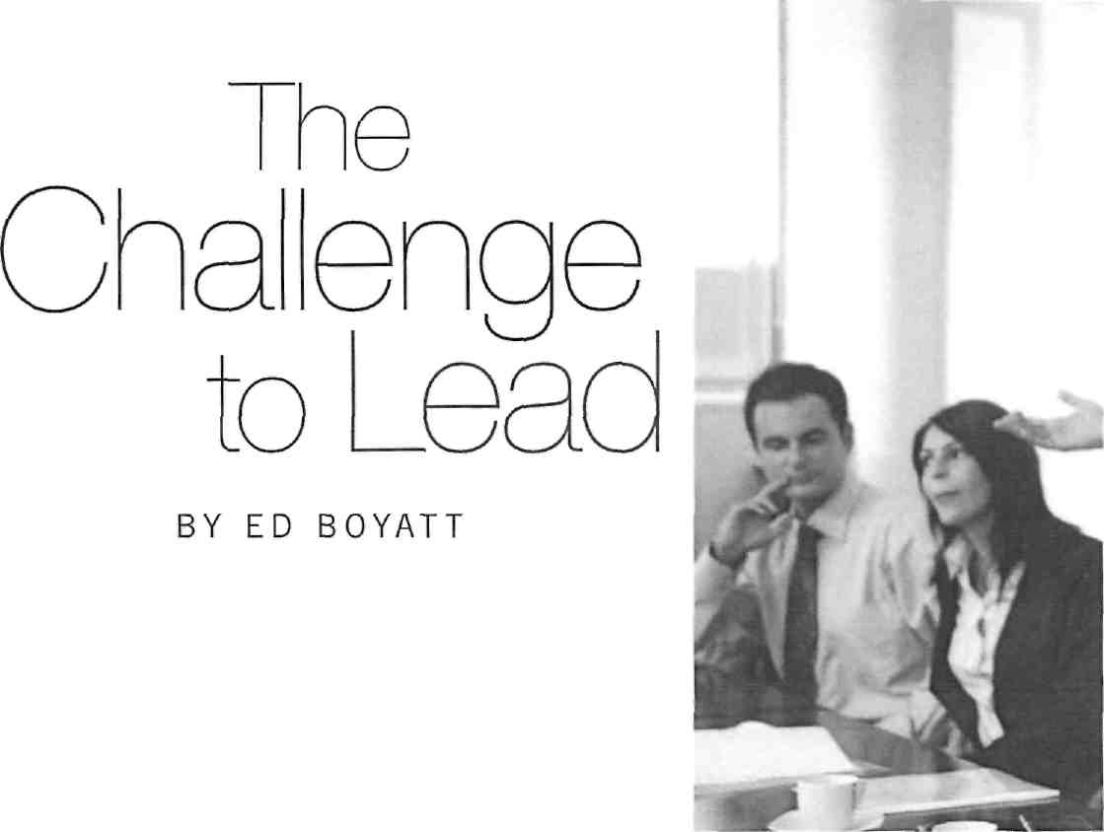
The purpose of a school board is to govern. When boards govern, are they leading or managing? Some observers think that many Advent-ist K-12 school boards over-manage and under-lead. Is this a correct diagnosis of your school board? To assess the accuracy of this statement, it will help to explore some key distinctions between leading and managing.
Leadership and Management
Analysis of management and leadership is a favorite topic in current organizational studies. Some experts believe that leadership and management involve the same behaviors. Others believe there is a profound difference between the two.
Our analysis begins by examining the root meanings of these two concepts. To lead means to go, travel, or guide. It implies movement, a venture into unexplored territory with unfamiliar destinations. A leader influences the direction and actions of a group of people.

The root of manage is a word meaning "hand." As James Kouzes points out, managing is about "handling" crises, maintaining order, keeping things organized and in control. By handling activities or things, one brings things about; he or she is in charge of or responsible for the completion of an activity.'
When boards govern, are they leading or managing?

Thus, there is a critical difference between leadership and management. Management has to do with "handling things," while leadership means "going places."
Let's be clear at the beginning of this discussion that despite the distinction between these concepts, school administrators and boards should value and perform both functions. Without good management, an organization tends to be chaotic, things "slip through the cracks," and resources are wasted. Good management brings order and consistency to the daily operations of a school. Just as children need order and consistency at home, everyone connected to the school benefits from good management.
But leadership is also vital to an organization. Leadership sets goals and establishes a vision and a direction for the school. Leadership challenges the status quo. Leaders are not satisfied with yesterday's success. They always seek to make things and people better. Since continual improvement is the hallmark of excellence, leadership is required if positive changes are to be implemented.
This is why, according to Peter Drucker, both leadership and management are es-

sential.² They both have to do with responsibility, accountability, and "getting things done." They are different, to be sure, but in the same way that the right hand is different from the left. They belong to the same body. A school will not be successful without superior performance in both areas.
School boards expect tasks completed on time and on budget. These are management tasks. Constituents expect predictability and order. But they also expect the principal and board to establish direction and to align people with the vision of the school. These are leadership tasks. Leaders motivate, inspire, and energize people.
Managers place a high premium on efficiency. They want to improve performance on tasks that are already being done. They are more interested in the "how" and the "when" than the "why." Leaders focus more on effectiveness. They want to make sure that people are doing the right thing— for the right reason. They value the "what" and the "why" of the behaviors of an organization.

The Journal of Adventist Education • Summer 2008
http://education.gc.adventist.org/jae


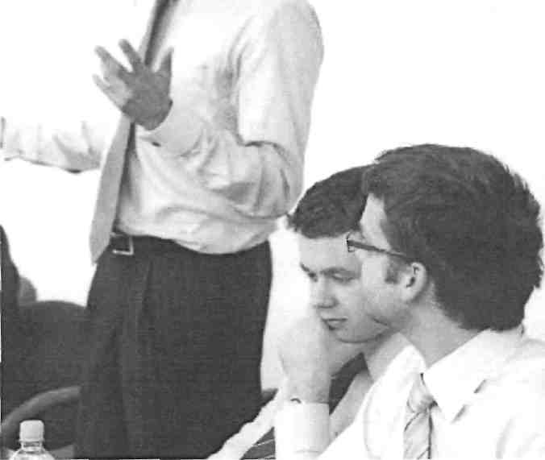
Management has to do with "handling things," while leadership means "going places."
input from the teachers and administrative team. This is what is required by conference offices of education and school accrediting agencies. Many schools establish a five-year plan of improvement that includes measurable goals each year.
A dilemma for some boards is what to do if the principal does not provide these school improvement goals. This is one of the times when the board must take decisive action. That's why board members are called trustees. The school and its future are entrusted to them. If a principal functions mainly by concentrating on managerial tasks, then the board must "take the lead" and assist him or her through vision-ing sessions to establish a five- to 10-year plan for the school.
Four Roles of a Board
Best-practices research and the literature agree that successful boards perform several critical roles:³ They must establish vision, find resources to support that vision, value accountability as they assess progress toward their vision, and be a credible advocate for the schools they serve. This article will review the functions of highly successful boards to show how both leadership and management skills are essential to perform these four roles.
1. Establishing a Vision
As noted in earlier boardsmanship articles in this journal,⁴ the school principal, along with the school board, must establish a vision or preferred future for their school. Since a quality school is always seeking ways to be more successful, effective school boards set school improvement goals each year. These goals are presented to the board by the principal, based on an annual review of the recommendations from the previous accreditation visit and
http://cducation.gc.adventist.org/jae
2. Sufficient Resources
After deciding on a vision or preferred future for the school, the board must (ind the resources to accomplish the measurable goals of that vision. For most Advent-ist schools, the sources of money are tuition, local church subsidy, conference subsidy, and fund raising.
Many schools have discovered that the easiest way to increase their operating revenue is by increasing enrollment. This is why school administrators and boards must demonstrate leadership in this area. Every board meeting should discuss some aspect of student recruitment. What measures can they take to make the school more attractive to Adventist students and parents as well as other Christians in the community?
Recruitment involves both luring new students to the school and retaining the ones already enrolled. While the principal and board demonstrate leadership skills in recruitment, the principal and teachers must demonstrate managerial skills in retaining the students already enrolled. Thus both leadership and management skills are necessary to meet the challenge of increasing and maintaining school resources.
H&,
Occasionally, schools have grown their enrollment without concurrently planning for the infrastructure and the availability of teachers to care for the expanding student body. Strategic growth plans must also include capital campaigns. Most Adventist schools have space for additional students and would not have an immediate need for additional infrastructure, but funds for additional teachers may be a challenge.
The board's role of ensuring sufficient resources for the school also includes establishing policies to supplement the division and union conference educational codes. These cover a number of areas, such as items to be included in the student handbook, tuition collection policies, and fees for the use of school facilities. Here again we see the importance of policy in the management of an organization. While it takes leadership skills to discover additional resources, it requires managerial skills to establish and implement policy effectively.
Since one of the board's responsibilities is to increase resources, a word should be said here about fund raising and school
7
The Journal of Adventist Education • Summer 2008

Best-practices research and the literature agree that successful boards perform several critical roles: They must establish vision, find resources to support that vision, value accountability as they assess progress toward their vision, and be a credible advocate for the schools they serve.
and annual evaluations of school employees. Most conferences and principals perform this management function in a professional manner.
development. Many school boards demonstrate leadership by hiring a developer whose main function is to establish contact with alumni and friends in the community in order to provide for the capital needs of the school. The board should consult with the local office of education if it feels it needs someone to per-
School boards should ensure the timely completion of these managerial tasks, but should generally delegate them to school administration. Superintendents generally
dent satisfaction can provide valuable information and suggest areas for improvement. Schools should also regularly assess the spiritual climate on campus. The short form of the Valuegenesis Survey is an excellent tool which, if conducted on a regular basis, provides a longitudinal spiritual profile.⁵ School boards must demonstrate leadership in achieving this major goal of Adventist education.
4. Advocate for Adventist Education
Boards need to take the lead in designing bold initiatives that share the school's story with the constituency and community. The distinction between managing and leading is obvious in this important area of board and school administration.

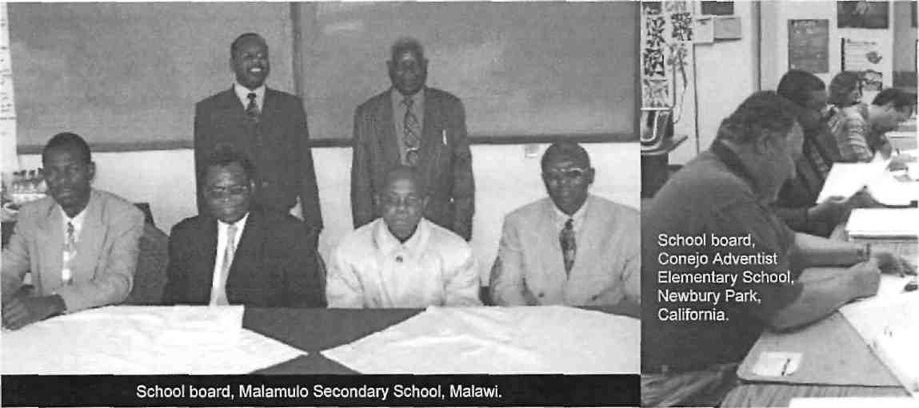

form these tasks. Most schools that hired such a developer saw the institution's future as brighter and more hopeful than if the board expected the principal or a volunteer to serve in that capacity. 1 challenge boards to show leadership in exploring creative approaches to fund-raising.

3. Accountability for Progress
Another major function of the board is to assess progress toward school improvement goals. This ensures accountability to parents, the constituency, the conference, and accrediting agencies. The principal and conference office of education oversee many of these essential assessments. This includes standardized achievement testing
ask the board to assist in their assessment of the principal's performance, but not in the evaluation of the teachers and staff. If a teacher complains to a board member about his or her evaluation, it is not the role of the board to question the principal's assessment or do its own investigation. The board should request that the superintendent perform an additional evaluation so as to have a second opinion to verify the work of the principal.
Another area where boards and principals show leadership is exploring how to ensure progress on school improvement goals. Annual surveys of parent and stu-
However, most boards would receive a below-average grade on this function. 1 challenge boards to dream big in this area. Some of those dreams may require additional revenue, but no better investment could be made to grow your school and ensure that members' children are enrolled in Adventist education. Are board members, principals, and teachers reporting to local congregations and church boards the good news from your school? The more widely shared the good news of Adventist education, the more likely parents will value a Christian education for their children. Boards need to find creative ways to take the initiative and demonstrate leadership in this essential role.

The Journal of Adventist Education • Summer 2008
http://education.gc.adventist.org/jae

Both leadership and management skills are essential to fulfill the four roles listed above, which are fundamental for effective school boards. They are the what, the how, the how well, and the marketing of Ad-ventist education. Establishing a vision of a preferred future is the what; ensuring an organizational structure to support the vision is the how; assessing the progress of the school programs that ensures accountability is the how well; and the communication of the importance of our youth and Adventist education to meet their needs is the marketing role of each board member.
Both the school board and principal must demonstrate leadership in these essential functions to ensure the development of a quality school.
boards be held to the same high standard? A board self-evaluation can be as simple as asking the following questions:
- What are our strengths? What is our board doing right?
- What improvements can we make to become a better board? How can we improve our effectiveness and efficiency?
- Is the board agenda filled with management or leadership issues? Does the board continually seek to improve its efforts? Or is the board expecting different results while conducting business as usual?
Some Final Thoughts on Leadership
A title does not make a leader. Just because a person has the title of principal or
them to act. This may be the reason that in many cases, the most powerful or influential person on the board is not the chair or principal. Influence comes with wisdom, vision, and the ability to communicate and inspire—not with position.
It takes a team. It is a grave misconception to think that leadership is a solo act. Leaders and followers engage in the act of leadership together. It isn't "I"; it is "we." True, a leader is the catalyst and cheerleader, but significant accomplishments are the result of a committed team working collaboratively to achieve a shared vision.
Persuade, don't command. Good managers and leaders both listen and use persuasive means for convincing followers. Good leaders know that the group with which

Valuegenesis²
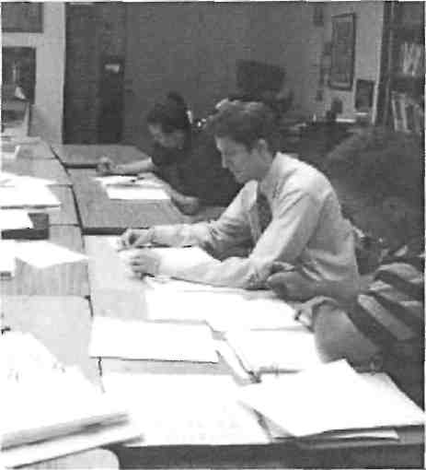
A SiWyo'f/w innuu/»«offamily. Cnurcft. srxJ Scttcof en .'.nr For."wi"c\T otFrX* in Sfwnrfi-iti'/Actse'ifizls
* Tfi» £rt**3 »i rap dlHtil Bfldin i*M Ifattfaitl Mil") tlOw *i If ngtlM A4*Mtf! MiiCHiM
ri-Mlri^lwiunc»r!W-ri^mifJv.ili«»vTr.r*3.'i.-i.T«t»>'«* Vnuirrnrw rrt ftow n*»c«i*dln take pm, and your c4Cp«rUIori |* vtrv impcttmu Wa acc*Kii» ya* hUpifl iris flsragt
* V«rai ycu mt n iris liiiif i inorrjro-jt av3 tanSOOltUL Ktf era W* bvet» aU*>to ar-taa
yait*ntt.trxiZi yrutrjana. V*r. * ntt stk fcr-fstr ti«mn, irdlmif wn m niretl oatai f«
OH Berflty jn*j cy nawe.
WTnnyinfflrAliiMolftcainw^nwl twpfemtfhanerwoetf o'-nvaito hm w
i£6fl6d U t>6 HiftSX* drib 1STYJutt UrZ F*fi4f Wn ili\ .. J yi-i utirti-i -ut\ la iiiii-
uHwri wilt tww pi rwnycttwre ttgrtftBl lwntj|vMib»:fe;t'cye>3 Nowirywpinr
u- tBXHA M * MM ;;o yOU H'anttDi,
' Flea*? ;*uwOi ALL cl>:51 on cri Ii;«i:-;j^ as coss tio. Dc o: as« in^co: c4>o tK» »►:> t*«u
\rr. ■t»iiH ut«Atr Wi sviirl In Vnrw YCJUH 1i*l-f|V T3IJR hr4 f*»: YOUR r^rtrrf
« Dif«»! n*mi *uiii 3-i* !«• mty ':•*• i!iw«lui Afl»M>tt +w :>uMi:'i m< urnm h»»l₍ H»»n tttt«» Qi&tfWtKrtMora.
* Anr. ihank yen la- h»la ng •-»!•

A Call to Self-Evaluation
Since assessment and accountability are important functions of the board, the members should find ways to evaluate their own effectiveness. In their eagerness to assess student progress and personnel, boards often neglect to evaluate their own work. Referring to the areas highlighted by this article, it would be wise to assess the board's deliberations to determine how much time is spent on management and leadership functions. Such an audit can produce large dividends.
School administrators are hired to both manage and lead in the affairs of the school. Principals are accountable for both managerial and leadership skills. Shouldn't
board chair does not guarantee that he or she will act like a leader. Some leadership skills are innate while others can be nurtured and developed. An effective leader needs vision, the ability to motivate people, empathy, the willingness to listen, a strong moral compass, the ability to collaborate to achieve shared goals, and the determination to earn the respect of the team. Hopefully people with a heart and skills for leadership will be elected or appointed to positions of leadership, for most are not born with these skills.
By definition, leadership is a journey and a process, not a position. Effective leaders do not need a title to connect with people and share a vision that inspires
they work needs to take ownership of the vision. This is best achieved through persuasion and participation in shaping the vision. Intrinsic and internal motivation always work belter than extrinsic and external control." Micromanagement and coercion rarely foster the relationships and climate that produce collegiality and collaboration. Leaders tend to empower the team rather than trying to command and control them. A leader looks for commitment, not compliance. Persuasion always wins out over commanding.⁷
Optimism about the future. Leaders are never satisfied with the present, for they envision a better future. This preoccupation with the future distinguishes a leader

http://educalion.gc.adventist.org/jac
The Journal of Adventist Education • Summer 200S

If a principal functions mainly by concentrating on managerial tasks, then the board must "take the lead" and assist him or her through visioning sessions to establish a five-to 10-year plan for the school.

from a manager. An individual may be a person of integrity who takes initiative and demonstrates the courage of his or her convictions; but these are not sufficient to make a leader. A leader is deeply dissatisfied with the status quo and restless for change. According to Marcus Buckingham, optimism is the essence of leadership. To be effective, a leader must be unfailingly, unrealistically, even irrationally optimistic.⁸ "This school will become bet-
ter" is the slogan of a school board that demonstrates leadership . . . followed by
"We will do whatever is necessary to accomplish this goal!"

 |  |  | —? V |  |  |  | ■**\ | I | - "SH^B
 |  |  |  |  |  | 1 | ■': ■■ | mm | ^{V} |  |  |  |  | M
. |  |  |  | ttk i? j | tmJ |  |  |  |  |  |  |  | ■-< '■
. |  |  |  |  |  |  |  |  | r |  |  | ■ | ■-< '■
 |  |  |  |  |  |  |  |  |  |  |  |  | ■',}
 |  |  | -!°:.V | Bgj |  |  | 1^_^J |  |  |  | W^ s | _i
 |  |  |  |  |  | ■?w
 |  |  | |7" **% | 1H C**>^B |  |  |  |  | W**1mmmm
 |  |  | ■
 |  |  |  | t ■ ' | [#J|
 |  | I | -. |  | $T?" >>j| |  |  |  |  |  |  | *
 |  |  | --..-^■M |  |  | m |  |  |  |  |  | ^^{m}'
 |  |  | ■

The Journal of Adventist Education • Summer 2008
http://education.gc.adventist.org/jae

Summary
An effective leader needs vision, the ability to motivate people, empathy, the willingness to listen, a strong moral compass, the ability to collaborate to achieve shared goals, and the determination to earn the respect of the team.
School boards and administrators require both leadership and management skills. The principals and teachers hired must be strong in both domains. But of the two sets of skills, leadership is the greater need. Most school administrators score above average in management skills, while falling short in the leadership area. It's much easier (and may seem more urgent) to keep busy "putting out the fires" while failing to investigate why so many are occurring—or to plan adequate measures for prevention!
Churches and schools must find board members and administrators who are pas-
sionate about school improvement and optimistic about the future. Leaders are needed who will dream big dreams and possess bold visions. This is what students deserve, parents expect, and what will gain God's blessing. 0
Dr. Ed Boyatt, Coordinator for
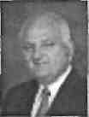
this special issue on school boards, is Professor oj Education at La Sierra University in Riverside, California, and Dean of the School of Education, lie has served as a pastor, sccondaiy teacher, academy principal, college dean of students, union associate director of education, and superintendent of schools.
REFERENCES
- James Kouzes and Barry Posner, The Leadership Challenge (San Francisco: Jossey-Bass, 2002).
- Stephen Covey The 8th Habit: From Effectiveness to Greatness (New York: Free Press, 20041. pp. 360-364.
- Sherry Loofbourrow. Boanhmanship: Maximizing School Board Leadership (West Sacramento, Calif.: California School Board Association, 1996), p. 10.
- Ed Boyatt, "The Principal as Board Officer." Journal of Adventist Education 66:5 (Summer 2004), pp. 10-14.
- Lcam more about this survey at the Hancock Center Website at http://www.lasierra.edu/ccntcrs/ hcym.
- Kelly Bock and Brad Greene, "Lead-Management vs. Boss-Management," Journal of Adventist Education 69:3 (February/March 2007), pp. 16-21.
- William Glasser, The Control Theory Manager (New York: Harper Business, 1994).
- Marcus Buckingham, The One Thing You Need lo Know (New York: Free Press, 2005).
Additional Resources
Board members should ask their principal or superintendent for information on effective boardsmanship. Most union offices of education have produced guidelines for boards in their territory. The con-

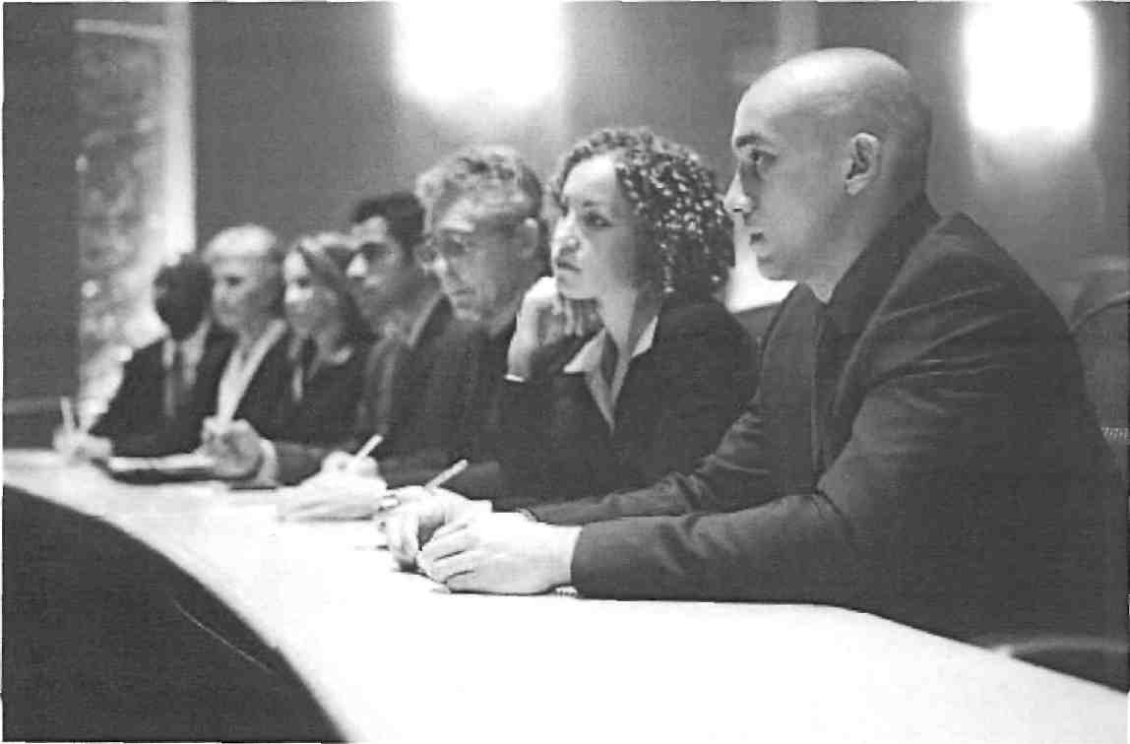

http://education.gc.adventist.org/jae

The Journal of Adventist Education • Summer 2008

ference superintendent should also have access to the excellent PowerPoint presentations produced in the North Pacific Union, and can refer to the North American Division Website for additional resources: http://www.nadeducation.org.
The National School Boards Association conducts regional and national conferences on boardsmanship, and publishes the American School Board Journal. Check it out at http://www.asbj.com.
Many states have a school board associa-
tion that conducts board member institutes and publishes a journal or newsletter. After you find the association in your state or country, 1 suggest you check out the California School Boards Association Website at http://www.csba.org.
Ralph G. Lewis and Douglas H. Smith, Total Quality in Higher Education (Delray Beach, Fla.: St. Lucie Press, 1994).
John M. Bryson, Strategic Planning for Public and Nonprofit Organizations (San Francisco: Jossey-Bass, 1995).
John Carver and Miriam Mayhew Carver, Reinventing Your Board (San Francisco: Jossey-Bass, 1997).
Boards 1 and II articles from the December 1999/January 2000 and Summer 2004 issues of the Journal of Adventist Education are available in PDF format on the Journal Website: http://education. gc.adventist.org/jae.
Many of the world divisions have developed boards handbooks. Contact yours for further information.

eming Boards of Universities and Colleges, 1980); Humberto Rasi editorial,Journal of Adventist Education (December 1999/January 2000), p. 3; and with thanks to Gerry Karst, Richard Osborn, Larry Blackmer, Hamlet Canosa, and Ed Boyatt for their input.
Responslbillties of a College/ University Board of Trustees
- To understand and clarify the mission of the school, making sure the philosophy and goals of the Seventh-day Adventist Church are being met.
- To review educational and public-service programs to ensure that they are mission-driven; and to approve new degrees and programs.
- To approve long-range plans (including purchase and sale of property) and engage in strategic planning.
- To appoint, support, and assess the performance of the president.
- To ensure the well-being of faculty, students, and staff.
- To ensure strong administrative and financial management:
- To hold the college/university in trust for the church.
- To interpret the campus to the community.
- To interpret the needs of society and the church to the campus.

- To occasionally serve as a court of appeal.
- To assess their own performance, and make modifications as required.
- To preserve institutional independence in harmony with the policies and goals of the sponsoring organization.
- To contribute to the school in two or more of the following areas: money, time, talent, and expertise.
Adapted from Perspectives on Trusteeship: Board Responsibilities in Private Colleges and Universities (Washington, DC: Association of Governing Boards of Universities and Colleges, 1991); John W Nason, "Trustee Responsibilities" (Washington, D.C.: Association of Gov-
Responsibilities of a K-12 School Board
_{v} 1. To clarify and help implement the mission of the school
- To work with the conference to find a good principal and teachers.
- To support the principal.
- To engage in long-range planning, and approve such plans.
,_{t} 5. To approve the educational program.
- To ensure financial solvency.
- To work closely with the principal and the conference in the employment and termination of teachers and staff as oudined in written employment policies.
- To maintain the physical plant.
- To enhance the school's public image and help recruit students.
1.0. To serve as a court of appeal.
- To stay informed.
- To contribute to the school in two or more of the following areas: money, time, talent, and expertise.
- To assess their own performance.
Code of Ethics for Board Members (all levels)
1. To uphold and help enforce de
nominational policies pertaining to ed-
¹ ucation, and to see that changes are brought about only through appropriate and ethical procedures.
2. To make decisions predicated
upon the welfare of staff and students,
and that meet the needs of all children enrolled in the school, regardless of their ability, race, sex, or social standing.
- To confine themselves to policymaking, planning, and appraisal, and to frame policies only after consideration of their potential effects.
- To support the chief office of the school and the staff while not interfering with the administration of the school.
- To make no personal commitments nor take any private action that might compromise the integrity of the board or damage the reputation of the school or church.
6; To conduct all aspects of the board's responsibilities in an ethical manner and not use their position or influence in a way that would expose the school or the board to liability or scandal.
- To maintain confidentiality on all matters discussed by the board in session.
- To refer all complaints to the president or principal and follow the church's established grievance procedures in major disputes.
- To support the school program by regularly attending board meetings, religious services, and other school-related functions.
10. To resist pressure by various
groups that seek to implement changes
in school policy that match their phi
losophy, that benefit them financially,
or that do not conform to church doc
trine and policy. &
Adapted from the Columbia Union Conference School Board Member Code of Ethics, provided courtesy of Hamlet Canosa.

The Journal of Adventist Education • Summer 2008
http://education.gc.adventist.org/jae

